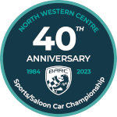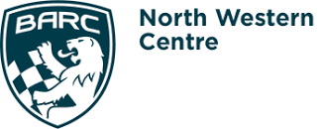

CNC Heads Sports/Saloon Car Championship – Rounds 6 & 7 – Oulton Park
ROSE BLOSSOMS BEFORE MONSOON ARRIVES
Qualifying
The warm summer sunshine at Oulton Park soon gave way to monsoon conditions in the afternoon. But Paul Rose had already secured another victory in his Saker, before race two was abandoned without a lap being completed.
The morning qualifying session was twice red flagged, but Rose was comfortably on pole by 1.112 secs over Andrew Southcott’s MG Midget Lenham. “It was just difficult getting a clear lap,” said Rose. “I was stuck in sixth gear after a couple of laps, due to a paddleshift power problem,” Southcott added. Steve Harris’ Saker and Simon Allaway’s Lotus Esprit V8 shared the second row. “I had an alternator problem as it wasn’t charging, it was lively under braking too,” said Allaway. “I just kept catching traffic in the wrong places,” Harris commented.
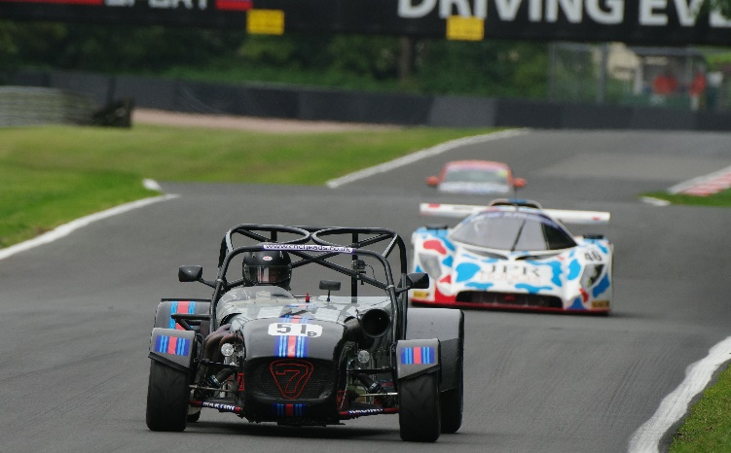
Roddie Paterson had sorted his driveshaft problem after Anglesey. “We had rebuilt the shockers and changed the diff, but it didn’t give me the balance I wanted,” explained the Caterham driver. He had Arron Armiger’s Vauxhall Tigra alongside. “A lot of traffic, but I got some good times and space as I bedded tyres in,” he said. Mark Primett had made some pre-race changes too on his Banks Europa. “It was my quickest time around here, but I needed more track time,” he reckoned.
“I had a bit of a scary moment at Druids, but it was hard work as I had a power steering issue,” explained Subaru Impreza driver Oliver Thomas, after going eighth fastest. But former double Champion Jamie Cryer was more than happy with his Ginetta G20. “No problems at all, so we don’t need any changes for the race,” he said.
Ric Wood’s Nissan Skyline was out for a pre-Goodwood shakedown and was 10th best, followed by Connor Modro’s Ginetta G40 and seasonal debutant Richard Hall in his Caterham. “I’m playing catch up, but hope it stays dry as I am rubbish in the wet,” Hall reckoned.
Marshall Groves’ Vauxhall Vectra ended the session prematurely, “a driveshaft exploded and the oil came up the screen. I thought it may have been the engine, so pulled in to save it,” he explained. Next up was Tim Foxlow’s Ford Escort RSR, “it was busy but I found a few gaps and the car felt much better,” he said. But just fractionally slower were Steven Parker’s BMW Compact, David Green’s Honda Civic and Ian Bamber’s Ginetta G20. “All good and staying on the same set up,” Parker added. “Absolutely on rails,” said Green.
Bod Buckby just edged out Connor Harvey in the Class C Caterham duel. “It was my fastest ever lap around here, so very happy,” said Buckby. But just behind them was David Clark’s Saker, after managing only two laps. “It was one real lap, then there was an issue with the paddleshift and it went into reverse while I was rolling forward, so I decided to stop,” he explained.
Julian Wood’s Kia Optima and Thomas Frankland’s Renault 5GT Turbo were due to share the next row, from Colin Robinson’s Ford Escort and Ric Walker’s Mini JCW. “Still confidence building, but making progress handling wise,” Walker admitted.
It was an all-VW row 13, with Paul Goodlad’s Scirocco heading the Golf of returnee Darren Scholes, “all fine,” Goodlad reckoned. Gary Warburton’s Mini Miglia and David Jones’ Ford Focus were behind them, with Clive Dix’s Mazda RX7 and Matthew Jones’ Ford Focus completing the top 30. Jones Junior had a problem back in parc ferme though, “the coolant was leaking,” he said.
“It’s the transmission issues again, but I can see the potential now,” said Dix. Helen and Brian Allen’s Fiesta and Puma had Octogenarian Bob Claxton’s VW Golf GTi splitting them, while Robert Wakelin’s Peugeot 205, Garry Wardle’s Seat Cupra TCR and Tony Harman’s Ginetta G20 all had problems. “It kept going into limp mode as a fuel pipe and fitting were blocked,” said Wakelin. “The front wheels were binding on the hubs from the start of the session, especially under loading into the corners,” Wardle explained. “My battery just drained and the replacement too,” Harman concluded.
Race 1
Both Allaway and Ric Wood were absent from the grid, and with Southcott pitting after the green flag lap, it was 34 cars that came under starters orders. “It was the electrics to the paddleshift again, it left me in sixth, so I had to pull in,” Southcott explained.
So Rose was on his own at the front,” I couldn’t see where he had gone, I was looking around to see where he was and then caught a glimpse of him in the pitlane,” said Rose. Rose was quickest off the start, but Paterson was close as they charged down the Avenue, with Thomas’ leading the chasers as the initial sort out began to settle on the Lakeside run to Island.
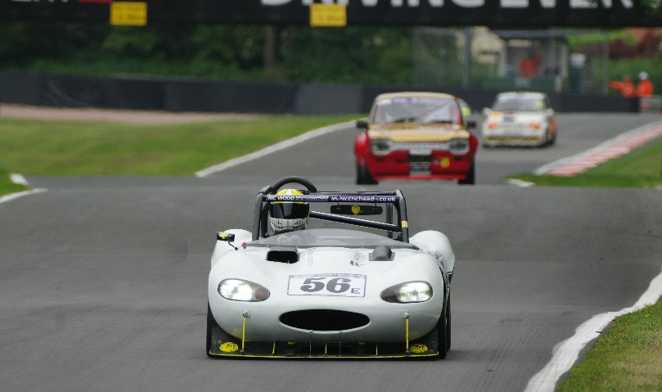
As they crested Hilltop for the first time the lead pair were already getting away, but Armiger was into third, from Harris, Primett, Thomas, Cryer, Bamber, Foxlow and Modro. The top seven held station onto the lap two, but Modro and Bamber had got ahead of Foxlow in the fight for eighth. Into Knickerbrook Modro was too late on the brakes under challenge from Bamber. He bounced over the grass at the chicane and retained eighth, with Bamber then losing ground to avoid possible contact. “I thought I was through, but had to back off when Connor came back onto the track,” said Bamber.
Having lost ground at the start, Harris was making up for lost time. “I got Arron for third on the start and finish straight,” he said, after starting lap three with Paterson as his next target. Scholes, Wakelin and Primett were all early casualties and with Primett’s demise, Thomas was back into fifth, but had Cryer closing in. “A hose had burst again,” said Wakelin.
Rose began to ease further and further ahead, which left Paterson and Harris nose to tail for fifth as they went up Clay Hill for the sixth time. “Into Lodge Roddie had the inside and I was on the outside. I wanted to switchback onto the straight and we came together as it didn’t work. I spun and stalled, then it wouldn’t restart, my race was done,” Harris explained.
Rose, Paterson and Armiger were left well clear at the front, but the Thomas v Cryer duel was being reeled in by Clark’s Saker, while behind them it was Modro, from Foxlow and Bamber rounding off the top 10, before a further gap to a three-car trio of Green, Hall and Parker.
“A cracking start and then I just had to manage the gap,” said Rose after taking victory by 30.618 secs over Paterson. “I had managed to hold the gap for a while, but couldn’t get anywhere near Paul,” Paterson replied. Armiger was happy with third, second in Class B behind Paterson. “I tried to outrun Steve’s Saker when he caught me, but knew he would get me,” he admitted.
Clark had a storming charge from 20th on the grid to hold fourth from lap nine, “exceptionally enjoyable battling through the field,” he said. Cryer finally got the better of Thomas for fourth over Hilltop, with three laps remaining, but they were still split by just 0.163 secs at the flag. Modro was the only other unlapped runner and had a brief exchange with Cryer before losing contact with the fifth-place duel. Unlike his recent races, Foxlow had a fairly solitary run into eighth. “A cracking start and I enjoyed the race, but a bit lonely,” he admitted.
Bamber took another Class E win from ninth, while Parker snatched the final top 10 place from Green on the last lap. “I lost the rear going into Druids for the final time and he got me,” said Green. “I lost ground with a spin exiting Lodge with three laps to go as well,” Bamber added.
“That was a great battle with Dave’s Honda and on the straights Richard’s Caterham kept pulling alongside too, but I had him in the corners,” Parker explained. Hall had remained close to the 10th place duel, while Buckby claimed the Class C bragging rights from Harvey. “He did get by when I took too much kerb at Knickerbrook, but I got him back over Hilltop,” he said.
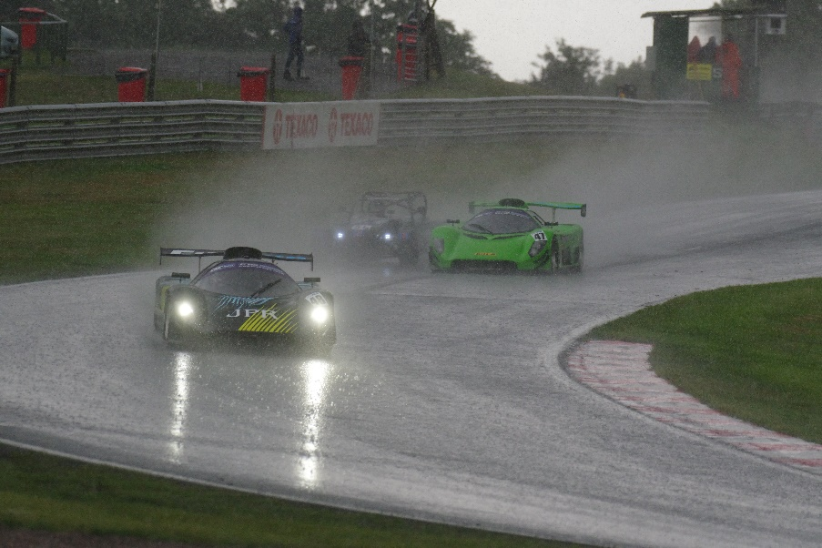
Walker and Frankland exchanged for 15th on the last lap, “I had an off at Druids,” Frankland admitted. Goodlad was just 0.196 secs of getting Frankland too, while behind him Robinson, Warburton, Dix and David Jones were all a lap down. “I had some good battles and it good to just stick in amongst them,” Warburton admitted.” I got to the finish but only managed to get two gears,” Dix added.
Matthew Jones, Claxton and Wood followed, with Brian taking the Allen family honours, after Helen had played catch up after a pitlane start. Groves had been just outside the top 10 when he retired after seven laps, before Harman and Wardle both joined the retirement list.
Race 2
Rain had threatened for much of the afternoon, but as the grid formed up it started to fall.
Both Southcott and Brian Allen pitted after the green flag lap, but as the lights went out, Rose had the lead again into Old Hall, from Paterson, Harris, Cryer, Thomas and Parker, with Armiger falling back down the order.
Before the field had managed to complete the first half lap, the rain had become torrential, the track was flooding and day had almost become night. There was no choice but to red flag the race, and with no sign of it abating it was game over for the day too.
https://www.tsl-timing.com/file/?f=BARC/2023/232727nws.pdf
Published by Peter Scherer for BARC North West, June 6th 2023

