

2016 PICKUP TRUCK RACING CHAMPIONSHIP



Organised by the British Automobile Racing Club

Thruxton Circuit, Andover, Hampshire, SP11 8PN

Published Copy

V8 - 11.02.16

CONTENTS

1 Sporting Regulations - General 1
1.1 Title & Jurisdiction 1
1.2 Officials 1
1.3 Competitor Eligibility 1
1.4 Registration 2
1.5 Championship Rounds 2
1.6 Scoring 2
1.7 Awards 4
1.8 Specific Championship Regulations 4

2 Sporting Regulations - Judicial Procedures 5

3 Sporting Regulations - Race Meetings & Race Procedures 5
3.1 Entries 5
3.2 Briefings 6
3.3 Practice 6
3.4 Qualification 6
3.5 Races 7
3.6 Race Starts 7
3.7 Practice or Race Stops 8
3.8 Safety Truck 9
3.9 Re-Scrutiny 10
3.10 Pits & Pit Lane Safety 10
3.11 Race Finishes 11
3.12 Results 11
3.13 Timing Modules 11
3.14 Specific Championship Conduct 11
3.15 Amendments for Oval Circuit Races 12

4 Championship Race Penalties 16
P1 Illustration 15

5 Technical Regulations 18
5.1 Introduction 18
5.2 General Description 18
5.3 Safety Requirements 18
5.4 General Technical Requirements and Exceptions 18
5.5 Chassis 19
5.6 Bodywork 19
5.7 Engine 21
5.8 Suspension 24
5.9 Transmission 25
5.10 Electrics 27
5.11 Brakes 28
5.12 Wheels/Steering 29
5.13 Tyres 29
5.14 Weight 30
5.15 Fuel Tank / Fuel 30
5.16 Silencing 31
5.17 Numbers and Decals 31

6 Appendices 37

2016 Pickup Truck Racing Championship

1. General

1.1 Title and Jurisdiction:
The 2016 Pickup Truck Racing Championship is registered & organised by the British Automobile Racing Club and administered by Pickup Truck Racing, in accordance with the General Regulations of the Royal Automobile Club Motor Sports Association (incorporating the provisions of the International Sporting Code of the FIA) and these Championship Regulations.

MSA Championship Permit No: 2016 / R039
Race Status: National B
MSA Championship Grade: C

The organisers reserve the right to issue additional statements in order to clarify items in the rules and regulations in accordance with MSA regulation D.11.1. All such statements will be issued to all registered drivers by post to the address detailed on the registration form or by delivery by hand or by email.

1.2 Championship Officials:

1.2.1 Championship Co-ordinator: Barbara Howard
Championship Manager: Sonny Howard
Championship Administrator: Melanie Ashley
Lead Truck Driver Stuart Bradburn

1.2.2 Championship Clerk of the Course: N / A

1.2.3 Licensed Eligibility Scrutineer Chris Baker
Technical Administrator Sarah Harris

1.2.4 Championship Stewards: Dennis Carter, Bill Coombs, Dale Wells, Guy Woodward

Any three of the Championship Stewards may sit to make a decision. In accordance with (G) 2.7, Championship Stewards may only adjudicate on any disputes, irregularities or appeals arising from the approved Championship regulations. Under (G) 2.7.1, Championship Stewards are also empowered to consider any request from the Championship co-ordinator to penalise any Competitor for any breach of Championship regulations after holding a formal hearing to impose a penalty in accordance with C.2.1.1 (subject to the rights of appeal provided for in Section C). Under (W) 2.2.1, the Championship Stewards can only adjudicate upon any disputes, irregularities or appeals arising from the approved Championship Regulations. They are also empowered to consider any request from the Championship Co-ordinator to penalise any Competitor for breach of Championship Regulations and after holding a formal hearing, to impose a penalty in accordance with C.2.1, subject to the rights of appeal to the MSC provided in Section C.

1.3. Competitor Eligibility:

1.3.1 Entrants must:
(a) be current members of the BARC and

(b) be Registered for the Championship and

(c) be in possession of a valid MSA Entrants Licences.

1.3.2 Drivers and Entrant/Drivers must:
(a) be current members of the BARC and

(b) be Registered for the Championship and

(c) be in possession of valid Competition (Racing) National B status Licence, as a minimum or

(d) A professional driver, in possession of a valid Licence (featuring an E.U. flag) and medical, issued by the ASN of a member country of the European Union, or comparable country. ((H)26.2.1, applies)

(e) If participation in the Championship requires absence from education a driver, in full time school education is required to have the approval of their head teacher and a letter stating such approval from their school in order to fulfil registration for the Championship. A driver shall not take time out of their education to participate in motor sport without the prior written approval of their education establishment.

1.3.3. All necessary documentation must be presented for checking at all rounds when signing-on. This will include both the competition licence and club membership card.

1.3.4 Competitors must ensure that their Trucks comply with the conditions of eligibility and safety throughout qualifying and racing.

1.4. Registration

1.4.1. All drivers must apply for registration as competitors for the championship by returning the registration application form with the appropriate registration fee to the address shown on the registration form. Applicants will not have the automatic right to be registered for this championship and it is required that, before purchasing a Truck, prior approval is sought from the Pickup Truck Racing Management.

1.4.2 The registration fee is £450 made payable to Pickup Truck Racing. The entry fee for each round is £360.

1.4.3 Registrations will be accepted at the discretion of the Pickup Truck Racing organisers from 1st Jan 2016.

1.4.4 Registration numbers will be the permanent competition numbers for the Championship. Each registered driver will be allocated a permanent number for the season by the Championship Administrator and these will be issued strictly upon receipt of a fully completed registration form and the appropriate registration fee.

1.5 Championship Rounds:

1.5.1 The 2016 Pickup Truck Racing Championship will be contested over Meetings as follows:

Event: Date: Venue: Organising Club:
1 | 27,28 March | Brands Hatch | BARC
2 * | 9,10 April | Rockingham | BARC
3 * | 28,29 May | Rockingham | BARC
4 | 11,12 June | Thruxton | BARC
5 * | 2,3 July | Rockingham | BARC
6 | 23,24 July | Donington | BARC
7 | 13,14 August | Silverstone | BARC
8 * | 17,18 September | Rockingham | BRSCC
9 * | 15,16 October | Pembrey | BARC
10 | 5,6 November | Brands Hatch | BARC

1.5.2 In accordance with D.11.1. the Organisers reserve the right to amend the published list of dates and rounds, in which case, all registered competitors will be informed of the amendments by official bulletin (see CR 3.5.2).

1.5.3 Events above marked with * will be for the “Oval” Championship while the remainder will be for the “Road-Course” Championship.

1.6. Scoring:

    - Points will be awarded to competitors listed as classified finishers in the final results as follows:

1st | 200 | 8th | 165 | 15th | 130 | 22nd | 95 | 29th | 60
2nd | 195 | 9th | 160 | 16th | 125 | 23rd | 90 | 30th | 55
3rd | 190 | 10th | 155 | 17th | 120 | 24th | 85 | 31st | 50
4th | 185 | 11th | 150 | 18th | 115 | 25th | 80 | 32nd | 45
5th | 180 | 12th | 145 | 19th | 110 | 26th | 75 | 33rd | 40
6th | 175 | 13th | 140 | 20th | 105 | 27th | 70
7th | 170 | 14th | 135 | 21st | 100 | 28th | 65

All other classified finishers will receive 20 points and all other starters will receive 10 points unless they were excluded.

1.6.2 Scoring points will be allocated for qualifying positions in each of the two qualifying sessions. Points will be awards as follows:

Fastest | Qualifier
1st | 20
2nd | 18
3rd | 16
4th | 14
5th | 12
6th | 10
7th | 8
8th | 6
9th | 4
10th | 2

1.6.3 To be declared as a classified finisher the competitor is required to pass the chequered flag on the race track completing a minimum distance of 80% of the race, rounded off to the nearest complete lap.

1.6.4 The totals from all rounds will determine the final championship positions in the “oval”, “road course” and overall championships

1.6.5 Ties for the overall championship will be resolved using the formula in the following order: -
a) Championship round wins
b) Race wins
c) Race second places, then third places, etc.

1.7. Awards:

    - All awards are to be provided by the organisers or Pickup Truck Racing.

1.7.2. Awards per round: A trophy will be awarded to the competitor who finishes in first, second and third place.

1.7.3 Awards for the championship:
A trophy will be awarded to each of the competitors who finish first, second and third in the overall championship. Please note: Any trophy winners who do not attend the Pickup Truck Racing presentation prize-giving at the end of the season (date and venue to be announced in the driver's newsletter) may be ineligible for any prize(s) which may have otherwise been presented at this function. Such prizes may be withheld and not re-presented to any other driver.

1.7.4 Bonuses:
The organisers reserve the right to introduce further awards and bonuses at any point before or during the season via the issue of an official bulletin to all registered competitors.

1.7.5 Presentations:
Trophies will be provided for the end of each race at a presentation ceremony. Drivers must attend any presentation for which the organisers have given reasonable notice. All drivers attending presentations must be in full drivers racing suits, correctly fastened. All team members asked to attend presentations must be in full team clothing. Presentations will be carried out as soon as possible after the finish of the race.

1.7.6 Title to all trophies:
In the event of any provisional results or series tables being revised after any provisional presentations and where such revisions affect the distribution of any awards, the competitors concerned must return such awards to Pickup Truck Racing in good condition within 7 days.

1.7.7 Entertainment Tax Liability:
Not Applicable

1.8 Specific Championship Regulations:

1.8.1 Competitors may be issued with specific times to park up their race transporters in the Paddock at each meeting. Arrival outside the set periods is allowed only with the specific approval of the Championship Co-ordinator. Wherever possible, the championship organisers will provide a paddock layout for the formula. This layout will define designated areas and detail positioning of team facilities within that area. Competitors will be restricted to these details and layouts.

Detailed Health and Safety Guidance Notes will be issued to competitors in advance of the first meeting. These must be complied with at all times.

    - Prior to event practice/qualifying all engines, gearboxes and final drive units will be sealed and the units identified to both the particular chassis they are being used in and the named competitor. This information is required to be entered on the vehicle declaration form with the respective tyre information. Should the seals be removed or a unit exchanged prior to racing the competitor concerned will forfeit their grid position and be required to start from the back of the grid. Where more than one competitor takes this penalty their position at the back of the grid will be determined by reverse Championship points order.

If any Truck is found to have seals missing, tampered with or the serial numbers are not as denoted on the vehicle declaration form for that event, during post race scrutineering, the competitor concerned will be excluded from the results with the exception of a situation whereby the Championship positions or results are being manipulated to gain or lose positions to benefit one or more competitors.

The engine must carry two seals, one fitted to the cam top cover and the other positioned at the front of the engine to seal the sump pan to the cylinder block, making it legible to read from the top of the engine bay.

The gearbox must be sealed by linking two of the tailshaft housing bolts together and the final drive must be sealed by linking two rear cover bolts.

1.8.3 The championship operates a success ballast system as per Technical Regulation 5.14. It is implemented by the championship management on the results of the first three positions in any race. For a Truck using a 2.3 litre Engine first position in any race adds 30kg, second position adds 20kg and third position adds 10kg. It is reduced in increments of 10kgs each time a truck carrying ballast finishes in less than third position in a race. The maximum permitted success ballast is 70kg. For a Truck running a GM 2 litre Engine there is no success ballast penalty, with one exception where a competitor has been competing with a 2.3 GM or Ford Duratec and for whatever reason changes to a GM 2 litre engine whereby they are required to carry any inherited ballast as per CR5.14.

2. Judicial Procedures.

2.1 Rounds
In accordance with Section C of the current MSA yearbook and the provisions of these Championship Regulations

2.2 Championship
In accordance with Section C of the current MSA yearbook and the provisions of these Championship Regulations

3. Championship Race Meetings & Race Procedures.

3.1. Entries

3.1.1 The organisers are responsible for mailing supplementary regulations to all registered competitors in sufficient time.

3.1.2 Grid line ups

- Qualifying part one will be used to determine the grid for race 1 at any event, with the six fastest qualifiers placed on the grid in reverse order and the remainder in the order they qualified in the practice session.

- Qualifying part two will be used to determine the grid for race 2 at any event, with the six fastest qualifiers placed on the grid in reverse order and the remainder in the order they qualified in the practice session.

- Where the race format consists of two heats and a final at any event, the grid for the third race (the final) is determined by adding each drivers points from race 1 and race 2 together with the grid formed from highest to lowest point scorer. The top six point scorers are reversed.

- With the exception of championship round 1, returning drivers to the championship will be required to start at the rear of the grid in the first race.

- Rookie drivers are required to complete a minimum of two events before they have the right to take a position within the grid and only once their times, abilities and race craft are to an acceptable standard. The decision will be made by the Championship Clerk of the Course and Championship Manager.

- Wherever possible, gaps created by missing drivers will be filled by re-arrangement of the grid, prior to being released to form up on the grid. Where the Clerk of the Course and/or the Stewards of the Meeting deem that a gap or gaps on the grid may compromise the safety of the race start, he/they may order that all Trucks assume a balloted grid position by reason of Force Majeure.

- Failure to meet the scheduled timetable for safety and technical scrutineering and/or the non-submission of eligibility, documented paperwork will result in forfeiting his/her allocated grid position. The competitor will be required to start from the rear of the grid.

- In the event that a practice session is cancelled, the grid will be determined by championship order with the six highest championship drivers being placed on the grid in reverse championship order.

3.1.3 If a competitor feels that either they or their Truck may be of detriment to the race by taking their allocated grid position, they must report the situation to the Pickup Truck Co-ordinator and the Clerk of the Course. As a result they can elect to start from the back of the grid but this is the only place that will be made available to them. No competitor may change places with another competitor to gain a better or lesser grid position.

3.1.4 When arranging the grid where a number of penalties have been imposed, the grid will be structured as:

- Grid positions determined by Championship qualifying
- Missed qualifying / practise
- Broken seals / tyre infringement
- Yellow card penalty – as detailed in 4.2.1 of these Regulations
- Elected to start at the rear of the grid
- Rookies
- New drivers joining the championship after rounds one and two

Where there is more than one competitor issued with a penalty, their grid position will be determined by reverse championship points.

3.2 Briefings:

3.2.1 The organisers will notify competitors of the times and locations for all briefings in the final instructions or supplementary regulations issued for the meetings. Competitors, crew chiefs and spotters must each attend all relevant briefings.

3.2.2 Any driver, crew chief and/or spotter failing to attend the briefing, unless specifically excused by the Clerk of the Course and/or the Championship Manager will be fined £50 and deducted 5 Championship points.

3.2.3 Championship regulations and specifications are subject to clarification via the official briefing at each event. It is the participants’ responsibility to be aware of clarifications so recorded.

3.3. Practice:

3.3.1. Each driver should complete a minimum of 3 laps of practice in the Truck to be raced. The Clerk of the Course and/or the Stewards of the Meeting shall have the right to exclude any driver whose driving is considered to be unsatisfactory - as per MSA regulation Q.4.5.

3.3.2. Should any practice session be disrupted the Clerk of the Course shall not be obliged to resume the session. The decision of the Clerk of the Course shall be final.

3.3.3. Practice times set will count towards the starting grid position. These will be determined in accordance with CR3.1.2 and CR3.1.4. Competitors will be notified of their grid position by means of a bulletin posted on the official notice board. The session will be twenty minutes in duration whenever possible. The session will be split into two sections.

3.3.4. Limitations to pre-race practice
Pickup Racing Trucks are not permitted to practice at any specific venue hosting a round of the Championship for a period of 28 days prior to the date of the Championship round, except for an official practice session organised by Pickup Truck Racing. There is no exception even when the circuit is being used in a different configuration or a different direction to that on the race day.

    - During official practise days, open practise or familiarisation, which relates to a round of the championship that has been organised by Pickup Truck Racing, there is no provision for a driver, other than the entrant to test or take out for practise a registered Championship Pickup Truck.

    - Should a competitor not be able to compete in an official open practice/qualifying then the competitor will be required to start the race from the rear of the grid.

3.3.7 An untimed practice session may be scheduled for an event, details of which will be advised in the competitor’s bulletin.

3.4 Qualification

3.4.1 The qualifying session will be divided into two sections with the break between the two sections being indicated by a union jack flag shown from the starting gantry and by radio communication from race control. Section one to determine the grid race one. Section two to determine the grid race two. Wherever possible all qualifying sessions will be a minimum of 20 minutes in duration.

3.4.2 Any driver that has incurred an infringement in familiarisation or practice, or whose pace is not of the required standard, relating to the grid position they have been allocated, can be moved to the rear of the grid.

3.4.3 Only one driver may drive each competing Truck at each Championship round. The driver must compete in the same Truck in the Championship races that was presented at Tech/Scrutineering and that was used for open practice/qualifying at that event. The chassis will be identified by the chassis plate and an official sealing tag fitted to the chassis and declared on the Technical Declaration Sheet.
.
3.4.4 Any driver who for whatever reason was unable to take part in the recognised practice/qualifying sessions will be required to start from the rear of the grid.

3.4.5 The organiser reserves the right to add additional qualifying sessions where it assists to promote specific events. Additional qualifying points may be awarded. When this is actioned, instructions will be given prior to the event via an official bulletin and again at the driver, spotter, crew chief team briefing.

3.5. Races

3.5.1 The standard minimum scheduled distance shall be 30 miles whenever practicable. Should any race distance be reduced, at the discretion of the Clerk of the Course or Stewards of the Meeting, it shall still count as a full points scoring round.

3.5.2 The races at each individual round will be programmed of equal distance. If for any reason, any race is reduced in distance, then this race will still count as part of the championship, without any adjustment of the other races in respect of equality of laps. This is done on the basis that every driver will race in each race; therefore any race reduction is equal for all concerned. The difference being that those who have been designated to start at the rear of the grid because of the results previously gained may have had less time to gain a better overall position.

3.5.3 At certain events it may be necessary to implement a different race format to assist in the development of the championship. Should it be required to implement a new format all drivers and teams will be informed in writing prior to the event and/or in detail at the driver/crew meeting at the event.

3.5.4 If for any reason a race cannot be run or deemed not to be run, then compensatory points will be awarded to all drivers scheduled in that race. These points will be calculated by taking the total number of points available for the race as per the points system, divided by the number of scheduled starters, all calculated to the nearest five points.

3.5.5 The Organisers reserve the right to change the programme outlined in the final instructions according to operational requirements of the Meeting subject to the approval of the Clerk of the Course, Championship Manager and the Stewards.

3.6 Starts:

3.6.1 All Trucks must be in the assembly area 20 minutes prior to their race, thus allowing Trucks to be positioned in their respective place on the grid. At the point that the Trucks are released to the grid any competitor who is not ready will be required to start from the pit lane.

3.6.2 All race start countdowns are to have a minimum elapsed period of 3 minutes from the time all Trucks are released to form up on the grid to the start of the pace lap in a 2 x 2 rolling start formation.

3.6.3 The countdown procedures/audible warning sequence should ideally be: -

4 minutes to start of Pace Laps - Trucks move into grid positions.
2 minutes to start of Pace Laps - Clear grid of all except officials.
1 minute to start of Pace Laps - “Start your engines” instruction and clear grid.

At certain events it could be necessary to implement a different start procedure to suit the event organiser’s requirements. Where this is the case structured instructions will be given at the drivers, spotter, crew chief briefing and documentation produced prior to the races.

3.6.4. The countdown and race start procedure may commence at the one-minute signal, with no team personnel allowed on the grid. Competitors are advised to check carefully supplementary regulations and final instructions for individual race meeting for details of variations to the start procedures

3.6.5 Any Trucks removed from the grid after the 1-minute stage or driven into the pits on the pace lap shall be held in the pit lane. They may start the race after the last Truck to take the start from the grid has passed the start line or pit lane exit, whichever is the later. No competitor may join the race from the pit lane after two race laps have been completed.

3.6.6 Any drivers unable to start the pace lap or start are required to indicate their situation as per MSA regulation Q.12.13.2. Any driver unable to maintain grid positions on the pace lap, to the extent that all the other Trucks are ahead of them, may complete the pace lap but must remain at the rear without any overtaking. Gaps on the grid will be filled by moving remaining Trucks forward, prior to the green flag. This action will be carried out by the Clerk of the Course via radio communication

3.6.7 The pace lap will be controlled by the Lead Truck. A Lead Truck is deemed to be a vehicle used to maintain grid formation and speed on the pace lap prior to the start of a race with a rolling start. It will be marked "Lead Truck" or "Safety Truck".

    - During the pace lap(s) drivers are to respect the position of other drivers around them, remain in their assigned row and not encroach on their position. At the end of the lap(s) the Lead Truck will pull into the pit lane and the driver leading the field is responsible for maintaining the speed established by the Lead Truck until seeing the green flag / lights at the start line.

All Trucks, following the commencement of the final lap(s), should be back in perfect grid formation as soon as is practically possible and must be in position at the completion of 50% of the final pace lap(s). The competitor occupying pole position (inside front row) is responsible for setting the distance behind the Lead Truck at the completion of 50% of the final pace lap(s) of approximately 30 metres. The Lead Truck observer will indicate if the distance is incorrect. The driver in the outside front row will draw level with the driver on pole. All following Trucks will line up neatly two by two, line astern, and approximately 5 metres behind the Truck in front of them. Trucks must maintain their grid positions at the speed determined by the Lead Truck. Falling back in order to accelerate is prohibited. Excessive weaving to warm-up the tyres, i.e. using more than 50% of the track width is prohibited and all weaving should stop at the completion of 50% of the final pace lap(s). Any driver deemed to be contravening any of these starting procedure rules would have committed a false start offence as detailed in Q.12.4 and will be penalised as in Q.12.5.

    - Upon successful completion of the pace lap the Lead/Safety Truck will retire to its designated pull-off point and the race Trucks will proceed, maintaining constant speed and formation until the signal is given by the starter that the race shall begin. Should the starter decide that, for whatever reason, the start of the race should be delayed then the start signal will not be given and one of the following courses of action will be taken: -

- If it is deemed safe to do so, the Lead/Safety Truck will be instructed to remain at the front of the
assembled grid for one or more further laps after which the race may be started.

- If, after the Lead/Safety Truck has retired and it is deemed safe to do so, the Lead/ Safety Truck will
be instructed to re-emerge at the front of the assembled grid and will proceed as in 1.

- If after the Lead/Safety Truck has retired it is not possible to proceed as in 2. above, the assembled
grid will continue to circulate maintaining constant speed and formation for a further lap and the Clerk of the Course communicating with the start line official will make a decision on the race start. Only after two laps have been lost will a decision be taken to reduce the race distance.

- After the race start has been given any overtaking move can only be made after passing the
pre-determined point announced in the drivers briefing. Where a competitor has not acquitted themselves well at the start, they must move to the inside of the circuit when safe to do so holding that position until they are able to build up a competitive speed.

3.7 Practice or Race Stops:

3.7.1 Should the need arise to stop any practice, red lights will be switched on at the start line and red flags will be displayed at the start line and at all marshals' signalling points around the circuit. This is the signal for all drivers to cease circulating at racing speeds, to slow to a safe and reasonable pace and return to the pit lane without overtaking.

3.7.2 Should the need arise to stop any race, red lights will be switched on at the start line and red flags will be displayed at the start line and at all marshals' signalling points around the circuit. This is the signal for all drivers to cease circulating at racing speeds, to slow to a safe and reasonable pace and return to the starting grid area which will automatically become a Parc Fermé area. Trucks may not enter the pits unless directed to do so and work on Trucks already in the pits must cease when a race is stopped.

3.7.3 Should the race be stopped for a tyre change due to adverse weather conditions a total of 5 minutes will be given before the pit lane is closed. The timing will be recorded by race control and the Clerk of the Course's decision is final.

3.7.4 It is the decision of the Clerk of the Course through consultation with the Championship Manager, to deem the race wet or dry. When the decision is made and it is said to be a wet race, it is the competitors’ choice to select which tyres he/she wishes to use in the practice or race, tyres may be mixed on any axle.
3.7.5 Case A - Less than two laps completed lap by Race Leader
The race will be null and void. The race will restart from the original grid, except that the grid will be formed in a single-file line. All competitors will be permitted to join the grid. The length of the restarted race will be determined by the Clerk of the Course.

3.7.6 Case B - More than two laps completed by Race Leader but less than 75% of race distance
The race will restart from a grid line up which was determined by the finishing order of part one (Q.5.4.2), except this grid will be formed in a single-file line. Only Trucks racing at the point the race was red flagged will be permitted to join the grid. The final results of the race (with penalties applied as appropriate) will be the finishing order of part two when chequered flag is shown.

3.7.7 If the leader has completed more than 75% of the race distance or duration it shall not usually be re-started (as per Q.5.4.3). If not re-started the results of the race will be based on the order of crossing the finish line at one lap less than at the time of the first showing of the red flag. Only Trucks which are under their own power at the time of the showing of the red flag will be classified.

3.8 Lead / Safety Truck:

3.8.1 The Safety Truck will be brought into operation to neutralise a race upon the sole decision of the Clerk of the Course. The Safety Truck will be driven by an experienced circuit driver (in accordance with Q.4.9.1) and will carry an observer capable of recognising all competing Trucks and who is in permanent radio contact with race control.

3.8.2 The Safety Truck, yellow / amber lights illuminated, will normally join and exit the circuit from the pit lane and the SC boards will be shown initially from the start-line. If these locations are to be varied specific written instructions and verbal briefings will be issued detailing the exact locations to be used.

3.8.3 On the order from the Clerk of the Course, the Safety Truck will join the circuit with its revolving lights on, regardless of where the race leader is.

3.8.4 When the order is given to deploy the Safety Truck a waved yellow flag and “SC” board will be displayed at the start finish line. The waved yellow flags and “SC” boards will flow around the circuit in both directions, as an adjacent post displays both their waved yellow flag and “SC” board. This system may be supplemented by a message being simultaneously broadcast to all marshals’ posts if such a communication system is available.

3.8.5 Flashing yellow lights may also be used at the start-line and at other points around the circuit.

3.8.6 All competing Trucks, when notified of the Safety Truck intervention (by the flag signals, “SC” boards, or by any other means) will reduce speed and line up behind the Safety Truck, no more than 5 Truck lengths apart, and maintaining the same speed as it. Overtaking or overlapping of any other competing Truck during a Safety Truck intervention is forbidden. Overtaking of a Safety Truck is forbidden unless the particular competitor concerned is signalled to overtake the Safety Truck by the observer in the Safety Truck.

3.8.7 When ordered to do so by the Clerk of the Course, the observer in the Safety Truck will wave past any Trucks between the Safety Truck and the race leader. These Trucks will continue at reduced speed and without overtaking until they reach the line of Trucks behind the Safety Truck.

3.8.8 While the safety Truck is in operation, competing Trucks may enter the pit lane, but may only re-join the track when signalled to do so and not when the safety Truck and the line of Trucks following it are about to pass or are passing the pit exit. A Truck re-joining the track must proceed at an appropriate speed until it reaches the end of the line of Trucks behind the Safety Truck.

3.8.9 The Safety Truck will remain in operation until at least the majority of competing Trucks on the circuit are lined up behind it.

3.8.10 When the Clerk of the Course calls in the Safety Truck it will extinguish the yellow/amber flashing lights prior to exiting the circuit. This would normally be such that a minimum of 25% of a lap for circuits over 2 miles and 50% of a lap for circuits under 2 miles should be completed by the Safety Truck with its lights extinguished.

3.8.11 Following the safety Truck extinguishing its lights, and prior to passing the green flag, the race leader will maintain the pace set by the Safety Truck. The race leader will dictate the pace and, if necessary, fall more than five Truck lengths behind it. In order to avoid the likelihood of accidents before the safety Truck returns to the pits, from the point at which the lights on the Truck are extinguished drivers must proceed at a pace which involves no erratic acceleration or braking nor any other manoeuvre which is likely to endanger other drivers or impede the restart.

3.8.12 As the Safety Truck is approaching the pit entry, the green flag will be displayed at the start finish line and the “SC” board withdrawn. Following this display of the start signal yellow flags and “SC” boards at the marshals posts will be withdrawn and be replaced with a waved green flag for one lap. The waved green flag will flow around the circuit in both directions, as an adjacent post displays their waved green flag. This system may be supplemented by a message being simultaneously broadcast to all marshals’ posts if such a communication system is available. Overtaking remains strictly forbidden until the start signal is passed.

3.8.13 The first three laps completed during the Lead / Safety Truck intervention will not be counted as race laps. After the completion of the third intervention lap, any further laps undertaken will be counted as race laps.

3.8.14. Under certain circumstances the Clerk of the Course may ask the Safety Truck to use the pit lane. In this case, and provided its yellow/amber lights remain illuminated, all Trucks must follow it into the pit lane without overtaking. Any Truck entering the pit lane under these circumstances may stop at its designated garage area.
3.8.15 While the Lead / Safety Truck is in operation, competing Trucks may stop at their pit, but may only re-join the track when the green light at the pit exit is on. It will be on at all times except when the Lead / Safety Truck and the line of Trucks following it are about to pass or are passing the pit exit or, at the end of the intervention, until the last Truck has passed the pit exit having passed the waved green flag. All Trucks re-joining the track whilst the Lead / Safety Truck is in operation must proceed at reduced speed until reaching the end of the line of Trucks.

3.8.16 The Clerk of the Course may impose a penalty upon any competitor or team who he considers has gained an unfair advantage whether inadvertently or not from a breach of these Lead/Safety Truck regulations. In the event that one competitor breaches these Lead/Safety Truck regulations for the benefit of another competitor then both may be penalised.

3.8.17 During a yellow flag period a competitor maybe requested to return to the pit lane for safety or technical inspection the competitor can be repositioned (given enough time) back in his or her grid position prior to the green flag restart.

3.9 Re-scrutiny

All Trucks involved in contact and/or incidents at any time during an event must immediately be taken to Parc Fermé to be re-submitted to the Scrutineers to obtain authorisation before continuing in the event or leaving the circuit.

3.10 Pits & Pit Lane safety

3.10.1. Pits: Entrants must ensure that the MSA, circuit management and organising clubs' safety regulations are complied with at all times.

3.10.2. Pit lane: The outer lane or lanes are to be kept unobstructed to allow the safe passage of Trucks at all times. The onus shall be on all drivers to take all due care and drive at minimum speeds in pit lanes.

3.10.3. Refuelling: Refuelling may only be carried out in accordance with the MSA regulation Q.13.1.1, circuit management regulations and the SR’s or final instructions issued for each circuit/meeting.

3.10.4 Pit procedure: A maximum of three crew members are allowed to work during practice/qualifying/races and all must be in team clothing. During a race, at no time while the Pickup Truck is in the pit lane may any member of the crew work on any component of the Truck that requires access via the underside of the Truck.

3.10.5 Under no circumstances may a Truck stop on the track or apron area for consultation with crew personnel or service and must be removed to the pit area. Any Truck or Trucks not involved in an incident that stop on the track, including the pit entry or exit, that requires a caution flag and does not need assistance will be assessed a three lap penalty. Any act of the driver, crew, etc. construed by the Clerk of the Course as a delay of the event will subject the competitor to disqualification and/or other penalty as described in these regulations.

3.10.6 Any Truck recovered to the pits from the race circuit may be permitted to continue in the race with the approval of the Clerk of the Course on the advice of the Eligibility Scrutineer.

3.10.7 It is required that everyone taking part in pit lane duties are wearing suitable clothing that cover their torso and legs at all times. It is required that everyone taking part in pit lane duties and/or who are a part of the grid presentation are appropriately dressed. Race teams, whichever driver they represent, need to be identically dressed in mechanic team wear. All other authorised personnel need to be in company/corporate uniform. All clothing is required to be clean and presentable, to represent the quality of the championship.

3.10.8 All major Truck repairs must be performed in the garage area of the pits. Once more than three personnel go over the pit wall the Truck must be placed in the garage area before being allowed to continue in the race.

3.11 Race Finishes

3.11.1 From the point in the race where the last lap flag has been shown to the race leader, the pit lane and all controlled areas that make up the access to the post race holding area will become Parc Fermé. This includes the podium area.

3.11.2 After taking the chequered flag drivers are required to progressively and safely slow down, remaining behind any competitor ahead of them. They should return to the pit lane entrance/ paddock entrance as instructed, comply with any directions given by marshals or officials and to keep their gloves and helmets on and safety harnesses done up while on the circuit or in the pit lane.

3.11.3 Once in the Parc Fermé area, drivers required for the podium presentations must proceed immediately to the podium. The drivers required will be those finishing first, second and third.

3.11.4 Unauthorised personnel (other than the Truck driver) are only allowed into the Parc Fermé area at the invitation of the Eligibility Scrutineer. Should unauthorised personnel be present in Parc Fermé, they render their Truck liable to exclusion from the event.

3.11.5 Trucks will usually be held in Parc Fermé for a minimum of 15 minutes after each qualifying session and race.

3.12 Results:
All practice timesheets, grids and race results are to be deemed provisional until the Scrutineers release all vehicles after post practice/race scrutineering and/or after the completion of any judicial or technical procedures and have been declared as final by the official organisers.

3.13 Timing modules:

3.13.1 All competitors will be required to fit electronic self-identification modules to their Trucks for the purposes of accurate timing. Holders for these and detailed fitting instructions will be issued with the transponders and it will be the responsibility of the competitor to fit these in the Truck on the inner front bulkhead on the right hand side with a signal hole of 40mm diameter in the floor to transmit the relevant signal. The modules must be in place and functioning correctly for all championship qualifying sessions and races. The setting and servicing of these items must only be carried out by properly authorised MSA licensed timekeepers. Competitors will be charged by the timing company for replacement of the modules due to misuse or loss at any time during the season.

3.13.2 Competitors may not place electronic timing equipment within five metres of the official start, finish or any other official timing lines at any event or test session/day. Nor is it permitted to place timing equipment on the top of any pit wall. Any such equipment placed within these zones will be removed.

3.14 Specific Championship Conduct:

3.14.1 It is the responsibility of the driver to ensure that his/her licensed spotter has signed on via the Pickup Truck Co-ordinator prior to practice and races of the event.

3.14.2 Verbal or physical abuse from any competitor or team member to any organising official or management personnel of Pickup Truck Racing will immediately be reported to the Clerk of the Course whereby disciplinary action will be taken (also see CR6.2.2i/6.2.2j)

3.14.3 The use of alcohol, controlled substances or drugs that may alter any individual’s ability to conduct themselves correctly or safely during an event is strictly prohibited. Under Pickup Truck Racing regulations any competitor or team member can be requested to undertake a medical examination by the circuit doctor. Failure to take the examination or the results of the examination finding that team member or competitor to be in violation of this regulation, the driver and team who he/she represents will immediately be excluded from the event and reported to the MSA.

3.14.4 Any team or driver failing to meet presentational standards may receive notice from the Championship Organisers requiring compliance and the timescale within which it is required. Failure to comply with such notices within the deadlines specified will render the competitor open to action from the Championship Organisers / Clerk of the Course.

3.14.5 If within 7 days of an event it appears from the official video recordings or from any other additional evidence that there may have been a breach of driving standards or behaviour, on or off the track, in a manner that the Championship Coordinator considers to have brought the Championship into disrepute, he may request that the Championship Stewards consider investigating an enquiry into the matter. This is not withstanding that the Clerk of the Course may or may not have already investigated the incident. Penalties may include individual race bans, loss of Championship points and / or end of season awards.

3.14.6 The Championship Organisers reserve the right to consider imposing further penalties on competitors proven by the Officials of any meeting to have behaved on or off track, in a manner considered likely to bring the Championship into disrepute.
Penalties may include individual race bans, loss of meeting or end of season awards. In the case of repeat offences the Championship Organisers reserve the right to request the exclusion of a competitor for a fixed number of races or from the Championship. In such cases no other competitors’ scores shall be adjusted.

3.15 Amendments / Additions for ‘Oval’ Circuit Races

The regulations found within this section CR 3.15 are considered as either replacements for or additions to other regulations published herein and only refer to races run on oval circuits.

1.3* Competitor Eligibility:

1.3.2* Drivers must be registered for the Championship and be, as a minimum, in possession of a valid 2016 MSA competition (racing) license (National B status) and have undertaken the approved PTR Oval Racing training course and gained accreditation to compete in Pickup Truck Oval Racing (CR1.4.1). Drivers must also be fully paid up Card holding “racing membership” members of the BARC.

1.3.3* Or, be a professional driver in possession of a valid Licence and Medical issued by the ASN of a member country of the EU (H.26.2.1) featuring the EU Flag, and have undertaken an approved “oval racing” training course and gained accreditation to compete in Pickup Truck Oval Racing. Drivers must also be fully paid up Card holding “racing membership” members of the BARC.

1.8* Specific Championship Regulations:

1.8.3* The Pickup Truck Co-ordinators will allocate pit boxes to all competitors from which to operate during practice and racing

3.2* Driver and Spotter briefings:

3.2.4* The role of the licensed spotter is to advise the driver of relevant track conditions (including flags or lights displayed and incidents ahead), the position of surrounding vehicles, any reshuffle needed during yellow flag / light periods to get Trucks into race order and to relay instructions from race officials. For the avoidance of doubt, in the event of his Truck being overlapped by another competitor the spotter must advise of the overlap either high or low. He must then get the driver to react to the situation and not block the other driver concerned hence allowing the overtaking or racing side by side.

The role of the Spotter is to ensure the driver’s safety. It is not the responsibility of the Spotter to make decisions for the driver nor is it part of their role to urge the driver to drive beyond their current pace. Any Spotter found in breach of this rule will be presented to the Championship Manager and/or Clerk of the Course and could have their license suspended or withdrawn.

3.2.5* The spotter must have gained certification by attending spotter training courses and be registered with Pickup Truck Racing. While operating as a spotter he will be dressed in suitable corporate clothing for the team that they represent. Headset ear covers must carry the number of the Truck they are spotting for.

3.2.6* All radio transmissions must be made in the English language. Should any conversation between a driver and spotter contain any language, foul words, considered unacceptable to be transmitted via the radio communication system, the relevant driver will be black flagged and, with the spotter, will be required to report to the Clerk of the Course whereby appropriate action will be taken.

3.2.7* It is the responsibility of the spotters to report to the person delegated as Chief Spotter on the day, if radio communication breaks down between the spotters and the drivers whereby the driver will be signalled by the starter to return to pit lane whereby he or she will be required to rectify the problem. Where communication has broken down during practice or a race and it is found that no action has been taken to rectify the problem it will be reported to the Clerk of the Course and both parties will receive a penalty.

3.3* Qualifying:

3.3.8* During any practise days, untimed practise sessions, qualifying and races, spotters must be operational at all times. They may only carry out their duties from the circuit denoted spotters designated area.

3.5* Races

3.5.1* The standard minimum scheduled race format shall be either two races of 35 laps or one race of 60 laps. Should any race distance be reduced, at the discretion of the Clerk of the Course or Stewards of the Meeting, it shall still count as a full-points scoring round.

3.5.3* At certain events it may be necessary to implement a different race format to assist in the development of the championship. Should it be required to implement a new format all drivers and teams will be informed in writing prior to the event and/or in detail at the driver/crew meeting at the event.

3.5.5* The organisers reserve the right to change the programme outlined in the final instructions according to operational requirements subject to the approval of the Clerk of the Course and the Stewards.

3.6* Starts:

3.6.1* In order to be allowed to start the race all Trucks must be in their grid position in the pit lane or the assigned holding area ready to participate, 20 minutes prior to their race with their spotter in position, in full communication with the driver and race control 15 minutes prior to the start time. During the pace laps Trucks will keep in formation with no overtaking and the pace will be set by the official Lead Truck. Any driver not ready to compete when called or whose spotter is not in accordance with the above may be sent to the back of the grid or excluded at the discretion of the Clerk of the Course. There will be three pace laps, the first lap being set at the controlled pit lane speed.

3.6.5* Any Trucks removed from the grid after the 1-minute signal or driven into the pits on the pace laps shall be allowed to re-join the Pace Laps taking up position at the rear of the grid unless otherwise directed by the Clerk of the Course. No competitor may join the race from the pit lane after two race laps have been completed.

3.6.10* After the race start has been given, any overtaking move can only be made after passing a predetermined point announced in the drivers briefing. Where any competitor who has not acquitted him or herself well at the start, they must move down to the low side of the circuit when safe to do so, to the inner white line, holding that position until they are able to build up a competitive speed.

3.6.11* In the event of any light failure the starter will revert to the use of the National Flag.

3.7* Practice or race stops:

3.7.2* Should the need arise to stop any race, red lights will be switched on at the start line and red flags /lights will be displayed at the start line and at all other signalling points around the circuit. This is the signal for all drivers to cease circulating at racing speeds, to slow to a safe and reasonable pace and return to the starting grid area in the pit lane which will automatically become a Parc Fermé area. Work on Trucks already in the pits must cease when a race is stopped.

3.8* Lead/Safety Truck:

3.8.5* As soon as the order is given to run the Lead Truck, all flag posts (including the start line) will display a yellow flag (or yellow lights); these will remain in operation until the intervention is over.

3.8.8* When the Clerk of the Course decides to call in the Lead Truck all yellow flags (lights) will be withdrawn and at the same time the Lead Truck will turn off its flashing lights and leave the circuit via the pit lane entrance at the end of that lap. The Lead Truck will not necessarily complete one full lap of the circuit with its lights off.

3.8.10* In all races yellow flag laps will count as racing laps.

3.8.14* Should due to an incident/accident on circuit and the circumstances invoke a situation whereby one driver overtakes another due to evasive action in an area that is accepted as a yellow light flag area the Race Director with the Clerk of the Course can reposition the Trucks in grid order prior to the race going green without imposing penalties.

3.8.15* During a yellow flag period it is the Spotters responsibility to get Trucks behind the Lead Truck into race order, with the leading Truck at the front of the train. This will involve the movement of some Trucks to establish the correct order and all Spotters must co-operate in this movement process instructing their drivers accordingly. The Clerk of the Course may insist upon certain positional changes and his decision is final. Any lack of co-operation will be penalised.

3.10* Pits & Pit Lane safety

3.10.2* Pit lane: The whole pit lane is to be kept unobstructed to allow safe passage of Trucks at all times. The pit lane is divided into three, the outer lane, inner lane and working lane. The onus shall be on all drivers to take all due care and drive below the speed limit in pit lanes. Entry to the pits is via the inner lane and exit from the pits is by the outer lane unless impeded by an outgoing Truck when you may remain in the inside lane until the end of the pit speed limit zone. The pit lane speed limit is 40 mph at all events unless specified to the contrary in the drivers briefing.

3.10.4* Pit procedure: A maximum of three crew members are allowed over the pit wall during practice/qualifying/ races and all must be in team clothing. Prior to the Truck stopping crew members may have one foot on the wall with all equipment under control, no equipment may remain permanently on the wall during qualifying and/or a race.

3.10.9* When making a pit stop during practise/qualifying or a race, Trucks may only stop at their allocated pit box. The driver may use the “courtesy corner” of an adjoining pit box on the entry to and exit from his pit box, if it is available for use, and it must not normally be obstructed by the team concerned. Drivers may not drive completely through adjoining pit boxes in order to get to or exit from their own pit box. For further clarification of the pit lanes and the “courtesy corners” please see illustration P1.

ILLUSTRATION P1.

Pit Lane Diagram:
Pit Box Diagram:
Racing Circuit
Inner Track Wall

Working Lane
Direction of traffic
Step over Wall

Inner Driving Lane

Outer Driving Lane
Cold
Pit
Lane
Hot
Pit
Lane
Cars should be parked near the centre of Pit Box when pit stop is taking place

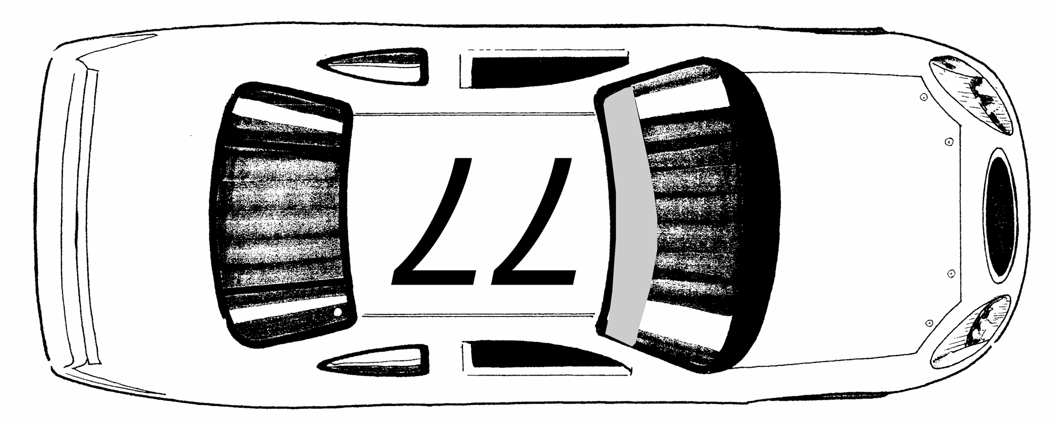
Working Lane

4. Championship Race Penalties:

4.1 Infringements of Technical Regulations:

4.1.1 Any competitor who fails to provide the correctly completed documentation or whose Truck fails comply with these technical specifications will be reported to the Clerk of the Course (and advised to the Championship Manager for info) by the Eligibility Scrutineer and may subsequently have his practice times excluded and/or forfeit his allocated grid position. When inspection is satisfactorily passed the Truck may enter the race but will be allocated the final grid position available. CR 3.1.4 will apply.

4.1.2 Any competitor who’s Truck does not meet applicable specifications at post race inspection will be reported to the Clerk of the Course by the Eligibility Scrutineer and may subsequently be excluded from that event under MSA regulation C.3.5.1(a) & (b), and hence lose all awards, monies and points earned, including winners circle monies. For infringements deemed to be of a more serious nature the Clerk of the Course and/or the Stewards of the Meeting are to invoke the provisions of regulation C.3.5.1(c). He may also be reported to the Championship Stewards for further investigation.

The organisers reserve the right to impound a competing Pickup Truck for inspection at any time for the period of time it requires to carry out safety and/or eligibility checks by the named officials or a technical officer appointed by Pickup Truck Racing.

4.1.3 No Truck can be presented for the start of any event whereby a body work repair is a creation of race tape or similar materials.

4.2 Infringements of non-Technical Regulations:

4.2.1 The Clerk of the Course (with advice from the Championship Manager) may take whatever action deemed appropriate to further the interests of fairness and finality in competition results. Such action includes but is not limited to the following

Revising the provisional race results, imposing penalties ranging through
a) Reprimand
b) Yellow card (see below)
c) Fine
d) Time penalty
e) Grid Place Penalty
f) Exclusion
g) Deduction of Championship points

A Grid Place Penalty may be applied in accordance with the 2013 Grid Place Penalty Trial as approved by Motor Sports Council, which includes the provision of “(C)2.3.2. At Race meetings, up to a 10 Grid Place Penalty may be applied at a driver’s future Race.”, (C)2.1.1. and (C)2.1.7. are extended in this respect

All such decisions can be subject to appeal in accordance with MSA general regulations. All penalties regardless of the infraction will be administered as close to the time that the infraction occurs as is practically possible.

In the event of the Clerk of the Course having some concern about driving standards during a race he will warn the driver concerned by the display of the black and white diagonal flag along with the display of the drivers number on a board shown to the track, the pit road and the spectators. This board when shown is equivalent to a yellow card.

Upon receiving a warning a driver may continue racing but the team spotter will be advised what the warning was issued for via radio communication and must advise the driver accordingly. Drivers should be aware that repeated offences may be penalised in accordance with these regulations.

Any driver receiving three yellow card warnings will receive a penalty, which will be imposed at the next attended event of the championship. The penalty is forfeit of the best grid position gained by qualifying and replaced by a position at the rear of the grid (CR3.1.4) and a deduction of twenty five championship points.

4.3 Protests and appeals.

4.3.1 Only an MSA licence holder (driver or entrant) may lodge an official protest or appeal. These protests or appeals must be lodged initially with the Championship Co-ordinator and with the Clerk of the Course or Secretary of the Meeting (with a copy to the Championship Coordinator) in accordance with MSA Regulations.

4.3.2 Any competitor who believes that another competitor has or will obtain a significant unfair competitive advantage by some action felt to be in violation of these regulations may protest such action. The protest must be submitted and will be dealt with in accordance with the MSA regulations.

4.4 Additional Championship powers.

4.4.1 The Clerk of the Course may order a position penalty for a transgression of the regulations at oval circuit events. The team concerned will be notified by race control and the driver notified by means of a penalty board at the start line. After notification the driver may cover no more than three laps before moving to the low side of the circuit and allowing overtaking on the high side until he is in the correct position as required by the Clerk of the Course. The Truck spotter must advise the driver in great detail during this process and particularly when he is able to resume racing.

4.4.2 The Clerk of the Course may order a back of lap penalty for a transgression of the regulations at oval circuit events. The team concerned will be notified by race control and the driver notified by means of a penalty board at the start line. After notification the driver may cover no more than three laps before moving to the low side of the circuit and allowing overtaking on the high side until he is in the correct position as required by the Clerk of the Course. The Truck spotter must advise the driver in great detail during this process and particularly when he is able to resume racing.

4.4.3 The Clerk of the Course may order a drive through penalty for a transgression of the regulations in accordance with MSA Regulation Q.12.6. The team concerned will be notified by race control and the driver notified by means of a penalty board at the start line. After notification the driver may cover no more than three laps before entering the pit lane, passing straight through the pit lane without stopping, adhering to the speed limit of 40mph, and then re-join the race. Where circumstances or time will not permit this penalty to be taken, a time of 25 seconds will be deducted from the respective driver’s final race results. As a result of either of these penalties no other judicial penalty will be imposed. It is not permitted to take a drive through penalty during a neutralised period in the race.

4.4.4 The Clerk of the Course may order that a driver be shown the black flag as prescribed by the regulations. For the avoidance of doubt this does not signify exclusion but does mean that the driver concerned must stop at his pit box within one lap and wait there for further instructions from the Clerk of the Course or his appointed representative

4.4.5 The penalties and procedures listed within regulations CR 4.4.1, CR 4.4.2, CR 4.4.3 and CR 4.4.4 above are not subject to appeal during racing and must be taken in the prescribed manner or be subject to further penalties in accordance with these regulations.

4.4.6 Any situation not specifically defined herein may be acted upon at the discretion of the Clerk of the Course, in accordance with MSA Regulations, and his decision is final subject to appeal in accordance with MSA Regulations. The Championship Organisers reserve the right to interpret and determine the true intent of all rules and specifications contained herein and will advise the Clerk of the Course of such. His decision may only be appealed to the Stewards of the Meeting.

4.4.7 The conduct of participants during any event that is deemed by the Clerk of the Course to be unsportsmanlike or in any way detrimental to the Championship and/or to the continuance of that event will be subject to the loss of points and / or prize monies. This decision may only be appealed to the Stewards of the Meeting.

4.4.8 The Championship Technical Officials and/ or their nominated deputy shall be given free and unrestricted access at all times and at any location in order to inspect or measure or impound any component fitted to any Truck registered in the Championship. Any costs incurred to refit inspected parts will be borne by the competitor as will the cost of any test if it proves that material content and/or a component is found to contravene the regulations.

4.4.9 Any competitor who is perceived to be attempting manipulation of events or the championship for the benefit of another competitor may be reported to the Clerk of the Course who will decide if there is a case to answer. Results will be declared provisional and will not be immediately altered nor penalties applied. However, due to the grave and weighty nature of such charges, and on the advice of the Clerk of the Course, the matter will be fully investigated at a later date by the Stewards of the Championship, who may, apply a range of penalties and / or alter results accordingly.

2016 Pickup Truck Racing Championship

5. Technical Regulations

5.1. Introduction:
The following technical regulations are set out in accordance with the MSA specified format and it should be clearly understood that if the following texts do not clearly specify that you can do it you should work on the principle that you cannot.

5.2. General description:
The Pickup Truck Racing Championship is for competitors participating in vehicles authorized by Pickup Truck Racing Ltd., supplied by SHP Engineering Ltd. and built expressly to comply with the championship regulations.

All vehicles must comply with MSA general technical regulations and the relevant parts of sections J and Q of the MSA yearbook except where specified below

5.3. Safety requirements:
The following articles of MSA Competitors Yearbook Section K safety criteria regulations will apply: -

Safety Rollover Structures - will be as supplied as standard with the Truck kit. Certificate number MSA 1616

Seat Belts - the only harnesses permitted are those of a five or six anchorage point type, to comply with FIA standards, K.2.1. The only anchorage points to be used are those fitted in the chassis by the licensed chassis constructor. It is a requirement that a suitable neck support system is used by all competitors that is effective for Pickup Trucks road circuit and oval racing. In addition at certain circuits a FHR device will be a minimum compulsory requirement.

Fire Extinguisher - the fire extinguisher must be an approved plumbed in type. (K.3.2) The only permitted position for the reservoir bottle is the area known as the passenger foot well located on the right hand side floor. It is to be mounted on the bracket plate supplied by the chassis constructor, the fixings to be strong enough to resist the rigors of Pickup Truck Racing. The pull cable or button must be placed beside the electrical cut out switch pull cable which is positioned just in front of the front windscreen and clearly marked. The cable/button inside the Truck must be within easy reach of the driver. The fire extinguisher must be armed at all times when on the circuit, in scrutineering, Parc Fermé and the holding areas.

Fuel safety cells - see section CR 5.15 of these regulations.

Tank fillers, vents and caps - see section CR 5.15 of these regulations.

External circuit breaker - see section CR 5.10 of these regulations.

MSA Yearbook K8, K9, K10 also apply.

5.4. General technical requirements & exceptions:

- Air jacks - the use of custom fitted air jacks is not permitted.

- At the start of each event, practice or race, each Truck will be presented in a manner that represents the formula. The organisers/management reserves the right not to issue the relevant paperwork to allow the Truck to be scrutineered if it is felt not to be of an acceptable standard of preparation.

- Selected engine builders, vehicle constructors and teams have to submit components and specification changes prior to them being used, in writing to the organisers of Pickup Truck Racing. They will or will not give authorisation as they see fit. Pickup Truck Racing reserves the right to exclude any component or development changes if it will adversely affect the formula in any way what-so-ever. Pickup Truck Racing via Eligibility scrutineering has the right at any time to exchange any part or item on the Truck that is a controlled unit, with a new replacement. This action would be taken to check the authenticity or specification of the original item concerned. The parts or item may not be returned. (see regulation 4.4.8)

- At each championship round, a number of engines can be selected at the discretion of the Eligibility Scrutineer and Pickup Truck Racing management, whereby the cylinder head will be requested to be removed, as will the sump pan to enable them to be checked for eligibility. Cylinder heads, cam covers and the sump pan must carry drilling holes to enable the Eligibility Scrutineer the facility to be able to seal the engine. These must be in an accessible position.

- Two Trucks may appear in the same colour scheme. It is possible for a team to share the same sponsor but the Trucks need to be presented in two different designs.

- No Truck will be permitted to compete in any practice or race when the clutch is non-operational or the starting system will not complete its function.

5.5. Chassis:
The only chassis permitted to be used is that supplied by SHP Engineering Ltd in left hand drive configuration. It carries the additional steel safety door protection plate, fitted in the left hand door aperture. The vehicle concept and design must not be changed in any way or form. No material may be added or removed. All relevant brackets must be retained in their original positions with no extension or adapters to allow for different applications. The brackets are to be used as originally intended. Any chassis repairs must be carried out by the licensed chassis manufacturer. The repair must be documented with a Certificate of Conformity being issued on completion of work carried out. It is the responsibility of the Competitor to make this information available to the Safety/Eligibility Scrutineer on request.

All chassis must use the two engine bay support towers to maintain the original shape and position of the bonnet. The towers must be fitted as designed with no modification whatsoever.

Resilient padding designed for roll cages (not pipe insulation) must be installed on any roll cage or frame member where contact can be made by the drivers’ helmet.

Flat bottoming of the Truck is not permitted where the engine is fitted with a dry sump system then it is mandatory for the chassis to be fitted with a guard. It must extend from under the radiator back to the rear of the sump pan. It is to be made in aluminium of a thickness to a maximum of 3mm held only by the chassis alignment bosses. This plate must be complete with no additional holes, slots or vents for cooling or aerodynamic gain.

No aerodynamic devices may be fitted to the vehicle whatsoever other than those supplied in aluminium kit format via the licensed chassis construction. This includes air deflection devices.

At the start of the race meeting the Pickup must be fitted with both protective floor panels as supplied by the manufacturer.

It is not permitted to drill or cut any type of holes into any parts of the chassis, roll cage or bracketing systems nor any components that are supplied under contract by the licensed supplier for any reason, especially lightening. Acid dipping of any component is not allowed (CR 5.4(3) CR 5.1).

5.6. Bodywork:
There are three configurations of body kit permitted for the 2016 Championship all built under licence and only available through SHP Engineering Ltd. The body styling must relate to the engine being used, Ford Duratec with Ford panels, GM 2.3 litre Pro 1 and GM 2 litre Pro 2 with Isuzu or Vauxhall panels. These are identified as:

- Ford Ranger Wildtrak
- Isuzu Rodeo Denver Max LE
- GM Vauxhall

Panels are not permitted to be thickened or be reproduced by any other company or persons.

Body panels repaired with race tape are unacceptable with the exception of temporary repairs carried out during a race and approved by the Eligibility Scrutineer and/or safety scrutineer. At all times the presentation of the Truck must be in keeping with the image and profile to which this Championship has been marketed. As a result of this it is permitted to make small localised surface repairs to the body panels. All body panels must be bolted together with steel bolts and nuts of a minimum diameter of 6mm. Contact washers must be used on both sides of the bolts and nuts.

    - No panels may be bonded together to form one piece nor is it permitted to add any type of tape over any panel joints. Stringent checks will be carried out to prove the authenticity of the panels, their thickness, shape and size. The front body panels may not be bonded together to form a one-piece front end. The same applies to the rear panels. It is permitted to remove excessive material from the returns of the wheel arches, leading edge of the side skirts and the wheel arch returns of the bumpers to gain the required tyre clearance, but there must be a minimum of 5mm of wheel arch radius remaining. Any flange bolted joint must have a minimum of a 20mm return along the entire length of the flange, the only exception permitted is where clearance is required around a chassis tube or front tyres. It is not permitted to drill holes for lightening purposes CR5.1 or add additional body panel mounts to certificated chassis.

It is permitted to fit a reinforcing chassis stay to the rear quarter panel to prevent the rear corner/rear quarter being trapped onto the rear tyre.
This is a controlled part supplied by the chassis constructor and must not be modified in any way.

The material masked by the skirt sill, this being the lower cab and the rear quarter panel, is permitted to be removed to a point of 30mm below the fixing line of the top of the skirt sill. The resulting aperture must be filled to provide a flame proof seal from both the engine and the rear compartments. The skirt sill can be butted to the underside protection floor panel.

The body shape and position will be required to comply with 2011 PTR body dimensions and align to the technical eligibility profile plates Part Number PTR/PP01 – PTR / PP02 – PTR / PP03. Images Illustration P8

Brake cooling ducts may be fitted to the front panel in the area replicated as a spot light to a maximum size of 100mm diameter. These are the only ones allowed.

The high intensity brake light (CR.5.10.1) may be fitted into the cab rear panel. See illustration P9

No other ducts, apertures or holes are permitted in any other panels including glass areas. The door cover panels must be fitted as original specification with all R clips inter-linked together on each panel. It is permitted to have a single hand holding slot of a maximum size of 120mm x 40mm in each door interior. At no time, whatever the weather conditions, may any door panel joints be taped or sealed.

The bonnet and rear cover panels can only be fitted with over centre type retaining pins – the bonnet must have two at the rear and three at the front. The bonnet must be fitted in the full closed position and correctly supported and aligned with the scuttle panel at all times. It is permitted to have the rear hinges fitted to the bonnet but it must utilise all five bonnet pins when closed. The rear cover and centre decking must be fitted with at least four retainers in each panel and must be in the shut position at all times. The ID labels inside the body panels must not be painted over and the serial numbers must be clearly visible for identification and documentation. Pickup Truck Racing uses a passive low frequency scanner coding system for all new produced body panels produced after 2009 for authenticity and tracing purposes. All Trucks competing in a race event must have the complete body painted at the start of any event. (CR 5.4.2)

5.6.2 The grill configuration is determined by the choice of body styling and must be supplied by SHP Engineering. Where Vauxhall body panels are fitted it must have a Vauxhall Vectra C part number GM13106533 grille fitted. The grille must be fitted as supplied with no additional materials added or taken away.

The following criteria must be met:

- Where there is an excessive amount of the original GRP material masking the parts that require cooling behind the grills, it is permitted to remove that material.

- No grills are permitted to be blanked off from the front face of the panels. The radiator must be fed with air via the top and lower grill apertures in the front panel with no restrictions whatsoever.

- It is permitted to add ducting to guide air from the front panel into the radiator. The ducting must comprise of four elements making up a top, bottom and two sides with no splitters or deflectors added. It is not permitted to control the air flow after it has passed through the radiator.

- The electric fan must be fitted on the side of the radiator closest to the engine.

5.6.3 The only permitted rear spoiler is the 2003 specification type which must be installed using the kit as supplied by the chassis manufacturer. The Spoiler must be fitted without the use of additional blocks or wedges to the rear panel of the Truck and at an angle of 120 degrees from the horizontal line made by the top edge of the body side panel. The spoiler must not be reduced or increased in size or modified to operate more or less efficiently.

    - Windscreen:
The windscreen must be fitted at all times It must be in a condition where vision is not impaired by scratches, cracking, chips etc. and is suitably clear at all times when racing. It must be either laminated or produced in polycarbonate/Lexan/Makrolon of a material thickness of 5mm. When polycarbonate/ Lexan/ Makrolon is used the windscreen must be fitted with a central reinforcing mounted bracket, attached to the windscreen down tube. This must be of a suitable strength to stand the air pressure created by racing.

The windscreen must have a de-misting facility for wet/damp conditions.

The drivers door must be fitted with a quick release grilling system made of metal with a hole size no larger than 80mm x 80mm square. The releasing catch must be made of metal and must be well defined by a yellow lanyard supplied by Pickup Truck Racing.

No Perspex or polycarbonate may be fitted at any time to the door window apertures.

The vehicle must be fitted with a windscreen wiper system, which clears the required areas to the front of the driver. It must be operational at all times. A metal upright, tubing size of 38mm that is placed in the centre of the front windscreen is part of the chassis and must be retained.

It is not permitted to fit any tubing, ducting or vents into the door window apertures whatsoever even if it is colour co-ordinated or clear. Front and rear glass must remain clear – dark or tinted glass is not permitted.

The cab must be fitted with a rear window 240mm in height and 800mm long +/- 50mm. This screen must be bolted in position and the glass fitted from inside the cab.

5.6.5. Mirrors:
The fitting of a wide angled rear view interior mirror and one rear view mirror on each side externally, is compulsory. These should be in keeping with the presentation of the formula and be of a size to offer peripheral vision to the rear of the vehicle. It is not permitted to drill the roll cage or chassis when fitting any mirrors.

5.6.6 Towing eyes:
All Trucks must be fitted with both front and rear 2009 specification towing eyes as supplied by the chassis manufacturer. They must be connected to the chassis using the chassis manufacturers mounting brackets with a single 12mm steel bolt. The towing eyes must be painted in a contrasting colour to the body/chassis and be clearly defined. All Trucks must have four lifting eyes fitted within the chassis, of a minimum thickness of 5mm, as designed and positioned by the chassis constructor. It is not permitted to remove the lifting eyes or reposition them and they must also be painted in a contrasting colour.

    - Seats:
Only competition seats are permitted. These must be fitted with approved mounting brackets. The seat must be firmly attached to the allocated seat runner within the chassis. Head restraints are compulsory and must be built into the seat. It is to be of a minimum height of 100mm higher than the driver’s eye level. For oval racing the headrest must be fitted with the right hand side head protector and must be padded, being of a suitable strength to stand the vigour of oval racing.

For oval racing the only permitted seat is of an aluminium type. This not only uses the four floor mounting point within the chassis but must also carry mounting points at the rear of the seat at shoulder height to the appropriate mounting fitted in the rear cab cross tubes by two mountings, making a total of six mounting points.

The seat must be positioned whereby the shoulder straps of the seat belt must be angled down from the seat to the wrap around seat belt mounting harness bar which is part of the chassis by a minimum of 10 degrees. See diagram P7

All seats must be fitted with a padded cushion of material with a thickness of minimum of 25mm. The padding must cover the seat where it makes contact with the body and must follow and be packed out to the contours of the driver’s body.

5.7 Engine:
Engine specifications: there are only three engines permitted at present. These being: -

- Vauxhall 2.0 litre, 4 cylinder, 16 valve DOHC unit. The GM code number is C20XE with standard bore size of 87.53mm and a stroke of 86mm. This engine configuration is known as Pro 2

- Vauxhall 2.3 litre 4 cylinder 16 valve DOHC unit, using a core GM engine code C20XE using performance kit P3b fitted with controlled crank shaft, connecting rods and pistons with a standard bore size of 87.53 and a stroke of 94mm. This engine configuration is known as Pro 1

- The Ford Duratec 2.3 litre 4 cylinder, 16 valve DOHC unit. Ranger code numbers US 9D-297-AC, EU 9G-293-AC and Mazda code L3720709 with matching cylinder head, with a standard bore size of 87.5mm and a stroke of 94mm. This engine configuration is known as Pro 1

The engines, although identified by the manufacturer code, must be a production item. Prototypes, special vehicle applications or homologation specials are not permitted.

The 2.3 litre Ford engine and the 2.3 litre GM engine can only be used with a performance kit of controlled components supplied by Pickup Truck Racing for the competitor or named engine builder to self-assemble. The controlled components in each performance kit will be identified by branding, manufacturers coding or Pickup Truck Racing branding and additional specification data.
The parts that make up the performance kits will be the only components permitted to be used in the build. No modifications are permitted without obtaining written consent from Pickup Truck Racing. Pickup Truck Racing reserves the right to control the development and to amend the list of parts in the performance kits to maintain power output and reliability and to ensure controlled costs are maintained.

The components that make up the performance kits are listed on appendix P2/P3a/b. Any changes will be issued to drivers via an official bulletin.

Engines must have drilling within the flanges of the block/sump to accept seals on either side of the engine block. In addition there must be two sets of drillings in the cam cover to also enable seals to be placed.

Any bolt within the Ford or GM engine configuration may be converted to stud and nut and vice versa on the condition that it is a direct replacement.

The engine builders or their companies are required to acknowledge that they are carrying out the task of supplying and servicing engines for the Pickup Truck Racing Championship by contacting Pickup Truck Racing Ltd on (01353) 861168. It is the responsibility of the driver to name the designated engine builder.

Where there has been a change of either engine type or engine builder it is the responsibility of the driver to contact Pickup Truck Racing and register this information.

PTR reserve the right to power test any vehicle or engine, these test will not be to determine if the power output complies with these regulations, but may be used to indicate whether further examinations, testing or restrictions are necessary.

5.7.1. Permitted modifications: As detailed in text.

5.7.2. Prohibited modifications: As detailed in text.

5.7.3. Location: The chassis brackets and the engine and gearbox mountings are controlled components supplied and fitted on the chassis by the licensed chassis constructor. Their positions must be maintained and they may not be modified in any way or form.

    - Oil/water cooling:
All radiators or cooling fluid containers must be forward of the front bulkhead. The radiator may be made from a combination of steel, aluminium and plastic. It must be of a minimum size of 350mm high by 640mm wide. It must be mounted in the designated position as per the chassis design using the original mounting brackets. Where a replacement radiator is used the top of the radiator core must be within 50mm of the original mounting brackets. The radiator must be fitted with a minimum of one electric fan. No mechanical fans are permitted. One single overflow pipe must be fitted to the cooling system and must terminate behind the left hand front wheel within 100mm of the ground. No additional water circulation system may be used other than the water pump positioned in the engine block, mechanically driven as per the original manufacturers design.

Oil coolers are free as are water to oil heat exchangers and accu sumps. These must be positioned within the internals of the engine compartment.

The Ford and GM Engine may be wet or dry sump. Where the engine is wet sump it is permitted to carry out modifications to allow the sump to carry more or less oil and high pressure high capacity oil pumps are allowed. When converting the engine to dry sump the oil pump must be a side mounted application. This pump is the only means of oil displacement allowed. The oil pump drive must be taken from the crankshaft pulley and must be made via a drive belt of minimum width of 25mm. (CR5.7.3 applies)

The dry sump oil tank is only permitted to be fitted in the area behind the cab on the designated oil tank mounting tray, this being to the right side directly behind the bulkhead. All oil pipes, feed, return and breathers must travel along the right hand side floor as close as possible to the gearbox tunnel. These pipes must be a braided reinforced type fitted with high pressure unions.

5.7.5 Engine Breather Tank

All wet sump engines must have the engine breather catch tank fitted within the engine compartment.

Where the engine is dry sump, the engine must be fitted with a breather pipe returning to the dry sump tank. The dry sump oil tank must have a breather catch tank adjacent to the oil tank and to the right hand side of the centre line of the Truck.

Breather/catch tanks must be empty prior to the start of any practice session or race.

5.7.5.1 Induction systems:
The Ford Ranger 2.3 Duratec engine must use the inlet manifold supplied in the Performance Kit. The manifold/induction system must be used as supplied with no modifications whatsoever. The only air cleaners permitted are those where the filter element assembly is fitted directly to the throttle body face.

The GM engine inlet manifolds are free and matching of manifolds to cylinder heads is allowed. The engine must use a controlled set of injected throttle bodies supplied in a performance kit with no modifications whatsoever as supplied by Pickup Truck Racing. Throttle bodies must be fitted with throttle return springs as per MSA J.5.4.2. No ram pipes or induction aids are permitted within or adjacent to the air cleaners, this includes the inlet manifold. The only air cleaners allowed are those where the filter element assembly is fitted directly to the throttle body face. This must be done without adaptation or modification. In adverse weather conditions only it is acceptable to add a deflector plate to restrict the water spray from entering the air filter elements. Performance related devices such as gas or water injection, additional fuel supplies or any other systems are strictly prohibited.

Air filters must be used at all times. The filter element section must be complete to eliminate the risk of foreign material entering the throttle body butterfly’s. It is not permitted to direct cold air via any scoop duct tube to the air filter.

5.7.5.2 Cylinder heads, pistons & bottom end components:
The only modification permitted to the Ford Ranger 2.3 Duratec engine is to machine the head to block face to recover a damaged cylinder head. On the Ford and Vauxhall engine the crankshaft journals may be ground to a maximum of 0.25mm (0.10 thou). A spigot bearing sleeve may be fitted. Cylinders may be bored to a maximum of 0.5mm (0.20 thou). Head gasket choice must be made from the standard range.

Cylinder heads on the GM engine may be polished, gas flowed or skimmed. The maximum compression ratio allowed is 11.5 to 1 with no tolerance whatsoever. The valves may be changed. The replacement material has to be stainless steel and must be a one piece valve. Valve stems are to be standard manufacturer's size but the section protruding below the valve guide may be wasted to the valve head.
Vauxhall inlet, 33mm max. Exhaust 29mm max.

The choice of valve guide material is free and it may be shortened in length to allow better gas flow but it must occupy the original position within the cylinder head casting. Valve springs may be replaced as may the valve caps and cotters. The material type must be the same as the original manufacturer's items.
Valve spring seats may be machined. Valve spring shims are allowed. Inlet and exhaust ports may not be repositioned nor may materials be added to the combustion chambers or ports.

It is permitted to modify the cooling system within the engine block and head of the GM engine. It is permitted to use an after-market cylinder head gasket which may be thicker than the production OE part. No gasket is permitted that measures less than the original OE part.

Wire rings and additional sealing devices are not allowed.

On the GM 2 litre Pro 2 engine camshafts are free. On the GM 2.3 litre Pro 1 engine the camshafts are a controlled part supplied by Pickup Truck Racing as part of the performance kit. Vernier cam pulleys are permitted for adjustment only. The cam must be driven by the original drive system using standard production parts. Hydraulic cam followers may be replaced with solid lifters. The cam buckets can be changed to a larger diameter to suit the cam lift. A maximum of 11.80mm of camshaft lift is all that is permitted; this will be measured as the difference between the maximum and minimum radius of the lobes when measured from the rotational centre of the camshaft.

The only camshafts permitted to be fitted to the 2.3 Ford Duratec and the 2.3 GM engine are those supplied with the controlled performance kit. See illustration P4, P5

With the exception of the connecting rods and pistons, for the GM 2 litre engine, the crankshaft and all bottom end components must remain as standard manufactured items. No modifications are permitted at all (CR 5.1).

It is permitted to replace the connecting rods on the GM 2 litre engine. The replacement connecting rods must be made from ferrous material and have the same dimensions as the original component. See illustration P6.

Machining or polishing of bottom end components is not allowed. Localised drilling and grinding is permitted to gain the correct balance of crankshafts and con rods. Heavy metal may be added to the crankshaft for the same purpose. On the GM engine the front pulley and dampers may be changed to suit the configuration of the oil pump pulley and the alternator drive. However, it is not permitted to change the size of the water pump pulley to one of a better ratio.

Pistons may be replaced on the GM 2 litre engine. Valve pockets are permitted. The pistons must be of a flat top type (this means flat from rim to rim) with a maximum bevel angle machined to the outer edge of the piston crown of 0.75mm to assist in head gasket clearance. The piston top must be parallel to the top of the cylinder block. This means no domes, step-ups or wedge tops or bowls within the piston configurations. The pistons are permitted to protrude the block.

The top face of the engine cylinder block may be machined but only to a maximum of 3mm from the original manufactured item.

The connecting rods on the 2.3 litre engines are part of the Performance kit. The only machining permitted is to reclaim the connecting rod on ovulation.

The pistons fitted to the 2.3 litre engines must be those supplied in the performance kit. These pistons must be machined to produce a flat top piston. Valve pockets are permitted. Compression ratio must be maintained within the maximum permitted of 11.5 to 1 for the Ford 2.3 Duratec and the GM 2.3 litre engine with no tolerance whatsoever.

5.7.6. Exhaust systems:
The Ford Ranger 2.3 Duratec exhaust manifolds are a controlled part and must be fitted without any modifications whatsoever.

For the GM engine the exhaust manifolds are free with the exception that the manifold must be retained within the confines of the front upper and lower chassis rails fitted within the engine compartment with an air gap of 25mm between any exhaust part and any suspension components. The internal diameter of the exhaust primary pipe is free but must remain constant from the exhaust port flange through the entire length of the primary pipe. It is not permitted to have any form of constriction or expansion sections in the primary and secondary pipes

The exhaust system on the GM and Ford Duratec engine must pass through the gearbox/propshaft tunnel and have a silencer fitted within 200mm of the terminated end of the tail pipe. The system may exit via either of two sources, either exiting the rear panel, angled to the ground by 35 degrees or terminating under the rear buck area of the Pickup Truck finishing behind the rear axle. It must be securely fastened to the chassis. The noise level must meet the criteria CR 5.16

Any part of the exhaust manifolds or exhaust system may be wrapped in heat barrier tape but a fire blanket or alternative system of containing heat other than that described above is not acceptable. It is not permitted to have any parts of the exhaust manifold or system coated internally or externally in any type of ceramic materials.

The internals of the removable tunnel must be covered in an aluminised heat barrier material and bonded in position as must the external faces of the foot well box with the engine bay front bulk head and the full internals of the tunnel.

5.7.7. Ignition systems:
GM 2 litre engine type C20XE must be fitted with the crank trigger disc that is bolted directly to the crankshaft must remain a standard production part, un-modified in any way. It must be fitted to the crankshaft as produced with no slot adjustments. The only disc allowed is part number VX90324721 and it is only permitted to be fitted with the electrical switch, part number Bosch 0261210030.

GM 2.3 litre engine type C20XE must use an external crank trigger part number N0309. The crankshaft front pulley must be used unmodified as must the signal switch and mounting bracket part number N3326. These are controlled components supplied by Pickup Truck Racing.

The Ford Ranger 2.3 Duratec uses a crank trigger system as original equipment. The crankshaft pulley / trigger wheel part number is N0308 fitted with a signal switch part number N3326. Both components are controlled items and are not permitted to be modified.

The only ignition systems allowed to be used are those built under licence by MBE systems on behalf of Pickup Truck Racing. These are only available from Pickup Truck Racing. The ECU pack is a controlled unit and must be installed in the position provided in the top of the dash.

There are three types of ECU, one for the injection version of the GM C20XE 2 litre engine known as Pro2, one for both the 2.3 litre GMC20XE and the 2015 2.3 litre Ford Duratec and a third for the 2016 2.3 litre Duratec. All have a fixed advance curve and a rev. limiter set at 7,500 rpm for all. Each unit is sealed and coded and the listing of the codes is held by the permit holders and the Eligibility Scrutineer for the championship.

Pickup Truck Racing organisers will hold a number of ECU units to match the engine being used. At the discretion of the Eligibility Scrutineer it will be requested that the competitor remove their own ECU unit replacing it with one supplied by the race organisers. No competitor will be permitted to leave that event with the respective ECU unit.
Doing so will relinquish them of all championship points, at that respective round, trophies and prize fund issued on that day and will also relinquish them of an entry at the next competing round of the championship.

All MBE ECU management boxes carry a certificate of conformity with a Pickup Truck sealing number. These are the only permitted units that can be used.
If any unit or wiring harness is found to be tampered with, resistors added, bypassed or replaced with another non certificated unit the offender will be reported to the clerk of the course and penalties will be actioned by the MSA and the championship.

The eligibility scrutineer has the authority to demand that any unit be exchanged, at any time, for one supplied by the Pickup Truck Racing organisers. The cost of inspection for any ECU found to be non-compliant when returned to the manufacturer for internal data inspection will be borne by the relevant competitor. See regulation 4.4.8

5.7.8. Fuel delivery systems see section CR 5.15.

5.7.9. The engines carry a single selling plate of £6500.00 (six thousand five hundred pounds) excluding VAT regardless of the type or specification it is built to. The only parts that are permitted to be removed are the wiring loom, alternator, starter motor and clutch. This action is implemented by Pickup Truck Racing management and done at their discretion. Failure to comply with this rule by a driver will mean their exclusion from the championship.

5.8. Suspension:
All suspension has to be used as supplied by the licensed chassis constructor. The suspension components, including the axle configuration, pick-up points, mounting brackets and the design of parts, cannot be modified in any way or form, except for those listed in CR 5(8)1. Reproduction parts must not be used. Lock nuts and suspension rubber bushes/nuts/bolts must remain a standard size, fitted, although a different rubber compound may be used for the bushes, this includes the material known as polyurethane. All bolts and nuts must be made of steel and remain as a standard production item.

5.8.1. Permitted modifications:

- All suspension components must have a minimum of 20mm of the rod end thread placed into each boss that make up the component

- Rod ends may be substituted but only if for an exact copy in all dimensions and specification to the original components Aurora XM8T (Wishbones / axle link bars), Aurora VCM8 (Axle watts linkage), Aurora VCB8 (Steering). No aluminium joints are permitted.

- Springs must be a single piece unit 2.25” (60mm) type. It is permitted to use a selected spring rate of: -

Front: between 700 pounds (318kg) and 900 pounds (409 kg)
Rear: between 180 pounds (82kg) and 300 pounds (136kg)

The length is free, but the spring must replace the original unit and fit in the same manner without any modifications whatsoever.

It is permitted to use a flat type spring assister up to a spring rate weight value of 5kg to maintain the spring caps in position. Progressive springs are not permitted.

- Front and rear anti roll bars are a controlled component within the chassis and are supplied by the chassis constructor. The front roll bar is not adjustable and it is not permitted to be modified to gain a different torsion value to roll bar via the drop links and in dry conditions the front anti roll bar must be connected at all times. There are options for 3mm, 4mm, 6mm and 8mm to suit the front and 2mm and 4mm for the rear. They must be mounted on the same chassis brackets using the same alloy blocks and the same adjusting system. No anti roll bars or shock absorbers may be adjustable from the driver's seat. It is permitted to race with rear anti roll bars disconnected or removed. When a race is declared “Wet” it is permitted to remove one of the front roll bar links.

5.8.2. Prohibited modifications:

- Telemetry or suspension mapping systems of any type are not permitted to be fitted to the Truck on race days, practice days or official test days.

- The only permitted shock absorbers are those supplied under licence from Gazmatic International Ltd, a controlled unit built to Pickup Truck Racing specification and have fitted Pickup Truck Racing documented eligibility seals.
- The shock absorbers must not be re-valved, re-stroked, have the oil changed or be modified in any way or form. Air may not be directed towards the shock absorbers and no additional brackets, cowling or materials may be added to make them work more or less efficiently.

- The only bump stops allowed are of a total of 30mm in length and it is not permitted to use them to control the ride height or the suspension movement.

5.8.3. Wheelbase/track:
The maximum front track width is 1775 mm
The maximum rear track width is 1760 mm
The total wheel base, centre to centre is 2692mm +/-8mm
All measurements taken at centre line of axles.

5.8.4. Ride height:
There must be a minimum clearance of 90mm for ovals when 9-0/25.0x15 tyres are fitted and 80mm when 8.5/23.5x15 tyres are fitted with the exception of the sump pan, guards or bell housing. Prior to ride height checks being carried out tyre pressures can be adjusted to a value of maximum pressure of 2 bars (28 psi) in all four tyres fitted to the vehicle. If a wheel and/or tyre is damaged they can be replaced with one of similar tyre wear prior to checking.

  - Transmissions:
The only gearbox permitted is the one commonly known as a Ford rocket gearbox, which was originally fitted in a Ford Sierra and Cortina 2.0 litre and must be of a four-speed configuration. It is permitted to use an aftermarket gearbox and tail shaft case in iron or aluminium as long as the reproduced unit is of the same configuration in its principle design as the OE part it replaces. The H pattern gear selection must be retained. The internals may be fitted with a dog or synchro-mesh engagement system.

The championship organisers reserve the right to introduce an additional gearbox fitted with compatible ratios to those already listed.

1st | 2.04 to 1
2nd | 1.54 to 1
3rd | 1.21 to 1
4th | 1 to 1

Using a tooth count of

Gear Ratio |  |  | Tooth count
 |  |  | Main shaft | Layshaft
1st | 2.04 |  | 25 | 18
2nd | 1.54 |  | 22 | 21
3rd | 1.21 |  | 19 | 23
4th | 1.00 |  | 17 | 25
Reverse |  |  | 31 | 16

OR

1st | 2.071
2nd | 1.529
3rd | 1.21
4th | 1 to 1

Using a tooth count of

Gear Ratio |  | Tooth count
 |  | Main shaft | Layshaft
1st | 2.071 | 29 | 14
2nd | 1.529 | 26 | 17
3rd | 1.21 | 23 | 19
4th | 1.00 | 21 | 21
Reverse Not given

All gearboxes must be fitted with a breather pipe feeding into a reservoir. The flywheel fitted to a GM 2 litre and GM 2.3 litre engine must be a steel replacement part fitted with a standard diameter, starter ring gear. The Ford flywheel is a controlled component and may not be modified or altered in any way.

The starter motor must be mounted in the standard position forward of the bell housing and be operational at all times.

5.9.1. Permitted modifications:

- The gearbox bearings may be changed.
- Gear levers may be changed to a quick shift system.
- Selector rails and forks can be replaced or uprated.

- The clutch is free but it must have drive plates with a minimum diameter of 7.25 inches.
- The clutch mechanism must only be foot operated except in the case of proven disability. The hydraulic slave cylinder is permitted to be internal or external to the bell housing.
- The gearbox must be drilled to accept the standard championship seals achieved by linking the tail shaft housing bolts together.
- It is permitted to fit a recycling oil pump for the purpose of cooling or to spray oil into the gear cluster. This pump may be mechanical or electrical. CR 5.4.3

5.9.2. Prohibited modifications:

- No automatic transmissions are allowed.
- No other additional electronics may be fitted within the engine management system, which would facilitate the engine to operate traction control systems.

5.9.3. Drive:
The only axle permitted is that supplied by the licensed chassis constructor and is to be maintained as original equipment with the exception of a maximum of 1/2 degree of negative or positive camber either side. Axle breathers are mandatory and must feed to a reservoir. The axle must be located by using all four original link bars. The position of the axle is determined by the main hoop of the roll cage to the centre of the axle and this must be 965 mm +/- 8mm and it must be placed equally from each wheel side to the centre line of the chassis. The only permitted rear wheel hubs are those supplied by the licensed chassis constructor and must be of the steel type. Locked, free or limited slip differentials are allowed. No one-off or development units are allowed. The only permitted final drive ratio is a 3.75 to 1 fitted into a Salisbury axle case as supplied by the Truck constructors (tooth count for this is 45 crown wheel 12 pinion).

The only permitted differential pan cover is one supplied by the chassis constructor, which must be fitted. It is permitted to fit a recycling oil pump for the purpose of cooling or to spray oil in to the pinion. This pump may be mechanical or electrical (CR 5.4.3 applies).

Drilled halfshafts are not permitted. The material content and the sizes of the differential splines of the halfshafts are free but must be a direct replacement not changing the original design or characteristics of its operations. The final drive must be sealed by linking the two rear cover bolts.

The axle must be fitted whereby the nose of the differential is angled down at the pinion by a minimum of 1.50 degrees. The measurement is taken at the pinion flange.

If the championship visits a venue where the final drive and gearbox ratios do not allow the engine to perform, Pickup Truck Racing management will make an alternative final drive ratio available to suit that venue.

5.9.4 The propshaft manufacturer/supplier is free, however they must be made of steel and painted White.

The propshaft must be a one-piece unit of a minimum diameter of 3.0 inches, (76mm), and fitted with appropriate universal joints to suit. Propshafts fitted with an internal bonded rubber section to relieve shock loading are accepted as a one piece prop shaft.

The tunnel must be fitted with a minimum of two full propshaft hoops excluding the chassis cross tubes at the rear of the tunnel.

5.10. Electrics:

5.10.1. Exterior lighting:
Two brake lights need to be fitted as shown in illustration P9. The brake lights to be used are a Ring Light part number RL014 and they are 80mm x 70mm. They are a square light and you may use an LED copy BUT they must be square and be the same minimum size.

The lights are required to be fitted on the inside of the rear window on the centre line of the glass as shown. If you already have the thin LED light above the rear window it can be retained and operational but it is extra to the new lights required to be fitted. It must be fitted below the roof line and in the centre of the cab rear panel, either externally above the rear window or internally on the inside of the window mounted as high as possible. It must be mounted horizontally, have a minimum surface area of 49 sq cm. and a maximum area of 98 sq cm. and a bulb rating of at least 21 watts intensity or equivalent LED with an uninterrupted lens area. CR 5.6.1

5.10.2 A bad weather light is required to be fitted under the rear back panel and be rearward facing fitted within 200mm of the most external point of the rear panel. The specification is a minimum surface area of 49 sq cm. and a maximum area of 98 sq cm. and a bulb rating of at least 21 watts intensity or equivalent LED and be operational at all times

5.10.3 Batteries:
A single battery only is allowed to be fitted to the Truck which must be of a suitable power rating to start and power the Truck at all times. The battery must be fitted within the battery mounting tray as fitted to the chassis by the licensed chassis constructor. A battery isolation switch must be fitted.
This must be operated via a stop cable positioned externally. Just in front of the windscreen there must be a facility for the driver to operate the switch from the driving position. Both switches must be clearly identified.

5.10.4 Generators/alternators:
An alternator must be fitted to the GM engine and must be operational at all times. The pulleys may be changed to vary speeds and different belt configurations may be used. (CR 5.7.5.2) (CR 5.1)

The Ford Ranger 2.3 Duratec engine must use an alternator fitted to the block in its original position. The alternator must use the original multi rib belt. The alternator can be either a replacement item with a change of pulley size or OEM component.

5.10.5. Starters:
Starter motors must be operational at all times.

5.10.6. Digital dashes:
LED/digital dashes are not acceptable nor is any facility to download information from the mechanics of the Truck. It is only permitted to use clock pointer style gauges. The dash must be full width and fitted as designed by the chassis constructor.

It is permitted to install additional instrumentation to monitor the contents of the exhaust gas provided that such equipment has no connections, either electrical or mechanical with any other system.

5.10.7. Lap recording:
A facility to record lap times is permitted to be fitted to the Truck. No other form of data transmission or telemetry is permitted. (CR 3.13.2)

5.10.8 Recording devices
The fitment of any form of visual or sound recording device or system may only be actioned after permission has been granted by the Championship Organisers. Where cameras have been allowed, these can only be installed to the interior of the cab area of the vehicle and may only be forward facing. There is a restriction to any advertising (Appendix 6.2.6). The dash must show the race number of the respective Pickup Truck the camera is fitted to.

The Championship Organisers have first rights to any camera material prior to the driver or team, whoever it belongs to. This material must be un-encrypted.

5.10.9 Radios:
All Trucks must be fitted with an operational radio system which must be supplied or accepted and certificated by Autotel Race Radios when practicing, qualifying or racing. The radio must be adequately powerful whereby communication is maintained between the driver and spotter at all times. The radios must be programmed to communicate on one single channel even if the radio has variable options and must be capable of being used within Pickup Truck Racing’s operational monitoring system.

In addition to the spotter being able to communicate to the driver of the Truck that he/she is spotting for, he/she must have a separate radio that is set to the race control designated channel that will be used to relay all necessary information via a faster response system to the drivers. Additional communication systems (including listen only systems) are not allowed during practice, qualifying or racing.

Radio transmission via driver to pit crew and pit crew to driver is not permitted although the pit crew is allowed a system for listening only to monitor conversation between the spotter and driver.

Radio frequencies used by a driver, team, manufacturer and/or any of their suppliers must be licensed by Autotel Race Radios, Unit M Loddon Industrial Estate, Loddon, Norwich, NR14 6JD Tel 01508 528837 for use in the UK by the appropriate regional office of the Radio Communication Agency. The Co-ordinator must be notified on the Championship Registration Form prior to the start of the season of the Radio Frequency and any sub-audible tone to be used by the driver and team. A copy of the License or Short Term Hire Agreement for the frequency must also be submitted with the Championship Registration Form.
The Coordinator reserves the right to request production of the original License/Short Term Hire documentation to verify the use of any frequency by a driver and team at any time during the season

The driver and team will at all times comply with the terms and conditions specified from time to time by the Radio Communication Agency for the use of their radio frequency.

In the event that a frequency used by a driver or team interferes with a frequency used by a local emergency service or other third party the driver or team shall forthwith change its radio frequency to a non-conflicting frequency. This must be to the satisfaction of the Co-ordinator and in accordance with the requirements and prior approval of the Radio Communication Agency.
The driver and team will be suspended from testing and qualifying and racing until a change of frequency has been effected and a copy of the approval of the Radio Communication Agency submitted to the Coordinator.

If a driver and/or team wish to change their frequency they must first obtain approval from the Radio Communication Agency and submit a copy of such approval to the Pickup Truck Event Coordinator.

It is not permitted to scramble radio speech transmissions or encode them in any way. All radio transmission must be made in the English language.

5.11. Brakes:

5.11.1 The only permitted brakes at present are: -

Front: Wilwood Superlite IIa Calipers
Part number: WW120-3194-1.38/1.38R (B2320)
WW120-3194-1.38/1.38L (B2310)

Rear: Wilwood Dynalite
Part Number: WW120-9689 -375/1.75 (B2430)
These are the only callipers permitted and the Championship Organisers reserve the right to replace with superseded items or use an alternative supplier.

Front discs must be a cast rotor in vent form.
Size 309.6mm diameter +/- 3mm and 20.6mm thick +/- 1mm.
Part number WW 160.5843 (B0320)

It is not permitted to carry out any modifications whatsoever to these discs.

Rear disc must be a cast one-piece solid type.
Size 240mm diameter +/- 3mm and 10mm thick +/- 1mm.

Part numbers, Right Hand B0301 Left Hand B0300

5.11.2. Permitted modifications:

- The brake pad and its material content are free.
- Brake duct tubing is permitted. The two front panel ducts are the only means allowed for cooling the
front brakes and hubs. It is not permitted to blank or restrict the airflow via the apertures placed in the front face of the body panels.

- Any air required to cool the rear brakes and hubs can only be taken from under the vehicle and only
be scooped via a duct system with an aperture total size 75mm x 150mm each side. The duct must be mounted in front of axle within 350mm of the rear brake caliper and no lower than regulation ride height.
- Electrical duct fans are permitted to be fitted that will force air to the brakes, hub bearing carriers
and wheel rims only.

- The braking system must operate efficiently on all four wheels. Brake proportioning valves are
permitted to be fitted in the front and rear brake lines. The fluid pressure must be displaced equally across axles either front or rear.

- A heat shield may be fitted to the chassis to protect the brake fluid reservoirs against rising heat
from the exhaust system.

- No mechanical fans are permitted.

5.12. Wheels/steering:

5.12.1. Permitted options:

1. The only permitted wheels to be used are those supplied by the licensed chassis manufacturer.
Option 1 is an aluminium three part wheel, the part number is W0310. As single components the part numbers are:

Outer rolled edge rim - part number W0340.
Centre - part number W0350.
Inner rim - part number W0320.

Option 2 is a single piece aluminium wheel – part number W0305
Option 3 is a two piece aluminium wheel – part number W0306

1. It is permitted to fit option 1, 2 and 3 wheels to the car at one time as long as the type of wheels are the same on the front and rear on either side of the vehicle.

2. The three piece wheel must be built as designed for Pickup Truck Racing with no modifications whatsoever.

3. It is permitted to change the colour of the wheels from the original manufactured colour. It is permitted to use a maximum of two colours and all wheels must be the same.

4. Pop-off valves are not allowed. No wheel spacers are permitted.

5. The wheels must be fitted with an open competition nut showing a full nut of thread.

5.12.2. Dimensions: 8.5" x 15".

5.12.3. Steering:
The only steering system permitted is that supplied as original equipment, there may not be any additions made to it or any modification other than shim spacers between the rack mounting blocks and the chassis mounting. The type of quick release steering wheel assembly is free and collapsible column spacers are acceptable. The fitting of steering wheels of different types/ sizes/ offsets is allowed, as is collapsible column adaptation. It is recommended that steering wheel nose pads are fitted.

5.13. Tyres:

5.13.1. Specifications:
The only type of tyre permitted is the Cooper Avon Pickup Sport 8.5/23.5 x 15 supplied in slick and wet specifications.

Part numbers: Slick 8880S or Wet 7321N

For the Ovals the only tyre permitted to be used when it is deemed to be a dry race, practise or familiarisation, is a 9.0/25 x 15 supplied in slick format part number 11677. This tyre must be fitted on all four wheels of the Truck.

These may not be cut or altered in any way from that supplied by the manufacturer. No tyre may be buffed, re-faced or trimmed by any mechanical or hand held device what so ever. Tyre warmers, space heaters or any similar devices for heating or softening the tyre compound are not permitted at any time. The use of any chemical mixture that is placed in the vicinity of, or applied to, the tyre, that would re-structure the compound of the tyre, is also prohibited. Any wet tyre must have a minimum of 3mm of tread across the face of the tyre for 80% of its width and 80% of the diameter of the tyre at the start of the race it is to be used in.

5.13.2 Nominated manufacturer: Cooper Avon Tyres

5.13.3 A total of six tyres are all that are permitted for use on race days and in official practice. Of these six tyres only one is allowed to be new, the remaining must be selected from those declared at a previous 2014 Pickup Truck Racing event. The tyres must have two barcodes fitted by the manufacturer at the point of production. The relevant coding and designated numbers must be recorded on the documented tyre sheets and registered with the Eligibility Scrutineer at scrutineering. At the time of practice, familiarization or racing no other slick tyres may be present in the pit lane or relevant garage.

The tyres fitted and used on the Truck at the end of the second qualifying section are the tyres that must be used for the first race of that event. CR 4.1.1 applies.

If the Truck is involved in an accident or incident which has caused damage to the tyres it will be at the discretion of the Eligibility Scrutineer/Technical Director and a representative of the controlled tyre supplier as to whether extra tyres may be allocated for use. Additional tyres to be used will be on a like for like basis and on the introduction of these tyres the original damaged units will be destroyed.

Where the race is deemed to be wet, (regulation CR 3.7.4), then the competitor has the choice to select their tyre from part numbers WET 7321N or SLICK 8880S mixing any tyre on any axle, or four Oval Slicks, part number 11677.

Every registered competitor, at their first round of the 2016 Championship is permitted to register a total of eight slick tyres, four of which may be new.

  - Weights:

5.14.1 The weight of the Truck, without the driver shall be a minimum of 885 kg and with the driver a minimum of 975kg. The weight of a Truck can be checked at any time during a Pickup Truck meeting, practice or post race scrutineering at which time no fluids or materials may be added or taken away. Where ballast has to be added, to bring the Truck to a regulation weight, the only permitted area to fit the ballast is in a flat plate format of a size of 360mm x 560mm, bolted to the four gusset plates in the floor on the right hand side of the Truck. It is the responsibility of the driver to make a declaration to the Eligibility Scrutineer of the ballast being carried whereby it will be sealed in place.

5.14.2 Success ballast is in a flat plate format, issued by Pickup Truck Racing via the licensed Eligibility Scrutineer or scrutineering administrator, regulation 1.8.4. Each plate will weigh 10kg and be of a size of 360mm x 560mm. The only area permitted to fit the ballast is as CR 5.14.1 bolted with four 12mm bolts to the four gusset plates in the floor on the right hand side of the Truck. The maximum success ballast permitted to be carried is 70kg. The quantity of ballast being carried must be displayed on the windscreen in the lower right hand corner even if it is zero. For Pro2 competitors the wording Pro2 must be displayed on the windscreen in the lower right hand corner.

Where ballast plates have been issued and have not been fitted or not taken to the respective round of the championship the competitor concerned may be subject to a fine of £50.00 for each plate, plus a loss of ten championship points and forfeiture of the drivers relevant grid position.

All ballast fixings must conform to J.5.15 as a minimum.

5.15. Fuel tank and fuel:

5.15.1. Types:
All fuel tanks must be fitted within the area of the designed mounting frame constructed in the chassis. The fuel cell may be changed from the original specification but must meet the following criteria:

- It is only permitted to carry a maximum of 46 litres of fuel.

- Fuel cells may not exceed the dimensions of the frame and that of the original fuel cell.

- Fuel caps must be of an approved type.

- All mounting brackets must be made of steel and of a material content and size to sustain the
volume of fuel being carried.

- Fuel lines must be of an approved type produced in a steel reinforced covering.

- Fuel tanks must be fitted with vent pipe with the exit below the fuel tank and be fitted with non-return
valves.

- A heat shield must be placed between the rear exhaust system and the fuel cells. This must also be
covered in a heat reflective mat.

- The only permitted injection fuel supply components are:

Injection Pump TCP020/3, SHP Part No. F1010
Pressure Regulator AIR008, SHP Part No. F3010
High Pressure Filter Bullet F1, SHP Part No. F3210

- Where an injection engine is used, all braided hose must be to a minimum standard of Goodridge
200 hose fitted with the same standard Goodridge type fittings.

- It is only permitted to feed the injector rail from one end.

- The maximum permitted fuel pressure for the Ford Duratec 2.3 engine or GM injection engine is 3.5
Bar. The injection engines must be fitted with a pressure test point on the main injector fuel rail with a -3 or -4 JIC male take off.

5.15.2. Locations: as above.

5.15.3. Fuel:
The only permitted fuel to be used is that purchased from a roadside service station as pump fuel, Super Unleaded with an octane rating of up to 99 (ninety nine) octane. This is to be used as purchased with no additives what so ever. Anglo American, Sunoco and/or any special mix fuels are not permitted. Random fuel testing will be carried out throughout the season either at race meetings or at Pickup Truck Racing test days and practice. Fuel samples will always be taken at the point the fuel enters the injection rail. See Regulation 4.4.8

5.16. Silencing:
Specification: as per MSA yearbook J.5.17

5.16.1 Where the exhaust tail pipe terminates at the rear axle, the sound test may be carried out using the 2m test. (MSA J5.18). At certain event or venues the decibel requirement may be set lower than the MSA in the UK.

5.17. Numbers & series decals:

5.17.1. Positions:
To be able to compete in Pickup Truck Racing Championship the Trucks must display competition numbers on each side of the Truck occupying the whole of the rear section of the door being of a size at least 20” high with 3” wide strokes. The race number must also be displayed on the roof of each Truck positioned square to the front screen allowing the number to be read directly from the front of the Truck. This number must be of a minimum size of 20" with 3" wide strokes. The left-hand headlight and rear light must also carry the driver’s race number.

The organisers reserve the right to require immediate action to clarify race numbers deemed to be unclear by virtue of the style, size or colour. Silver or gold foil type or reflective number decals are not permitted. Advertising and graphics are not permitted on the sun visors, the rear of the cab, the roof, and within 350mm of the rear edge of the front wings and 220 mm of the leading edge of the doors. These are all areas allocated to Pickup Truck Racing to advertise the products and/or services of sponsors associated with the championship. These will be placed in a uniform manner as laid down by the Pickup Truck Racing organisers.

5.17.2 All race transporters must clearly show the number assigned to the Pickup Truck and team it represents.

5.17.3 All Trucks must have fitted head lights and rear light graphics. These must mirror those of manufactured vehicles. Clear/white rear light graphics are not permitted.
5.17.4 No sign-writing is permitted on the roof of the Truck except for the race number (size see CR 5.17.1) and the driver’s name, which must be written on each side of the roof in a size not to exceed 350mm x 90mm.

    - No advertising, colouring or obstructions may be added to any clear areas or glass other than those specified.

    - It is permitted to add material to the front windscreen decal to aid visibility in bright sunlight. This material must be in the same colour as the respective windscreen decal and must be across the full width of the front screen.

5.17.7. Suppliers:
All championship sponsorship wing and door decals will be supplied by Pickup Truck Racing Ltd. Where fitted they must not intrude onto the door race number or vice versa.
P2 Ford Duratec Engine Information

ITEM | SHP NO | QTY | DESCRIPTION
1 | F4004 | 0 | THROTTLE BODY KIT CONSISTING ITEM 2 - 8
2 | F4005 | 1 | MANIFOLD
3 | F4006 | 1 | T BODY TWIN 45MM
4 | F4007 | 4 | INJECTOR POCKET PLUG
5 | F4008 | 4 | AIR HORN
6 | F4009 | 1 | SENSOR - THROTTLE POSITION
7 | F4010 | 1 | LINKAGE KIT - INCLUDED THROTTLE CABLE
8 | F4011 | 1 | LINKAGE BRACKET AND ROD
9 | F4315 | 1 | SET OF FOUR INJECTORS
10 | F4322 | 1 | INJECTOR RAIL
11 | H3421 | 2 | ADAPTOR - 741 BSP MALE - JIC MALE 1/2 10
12 | H3450 | 2 | ADAPTOR - AN816 BRAKE CALIPER 03
13 | H3680 | 1 | ADAPTOR FP192 SPECIAL FUEL RAIL
14 | H4250 | 1 | CAP 315 BSP FEMALE
15 | H6402 | 2 | DOWTY SEALS 22MM
16 | H8055 | 1 | CAM BOX BLANK
17 | H8301 | 1 | UNION ENGINE BREATHER CAM BOX
18 | N6340 | 1 | BOLT SET SUMP
19 | N0301 | 1 | DIPSTICK
20 | N0302 | 1 | DIPSTICK FITMENT SLEEVE
21 | N0303 | 1 | DIPSTICK TUBE
22 | N0305 | 1 | FLYWHEEL
23 | N0320 | 1 | CAMSHAFT INLET/EXHAUST & VALVE SPRING KIT
24 | N0345 | 1 | PISTON AND RING (4 OFF SET)
25 | N0348 | 1 | CONNECTING RODS (4 OFF SET) ARROW
26 | N0349 | 1 | CONNECTING ROD BOLTS (4 OFF SET)
27 | N0350 | 1 | CONNECTING ROD BEARING SET - ENGINE BUILDER
28 | N1390 | 1 | AIR FILTER
29 | N1391 | 1 | AIR FILTER BACKING PLATE
30 | N3320 | 1 | ECU MANAGEMENT BOX
31 | N3321 | 1 | WIRING LOOM
32 | N3330 | 1 | AIR TEMP SENDER
33 | N3331 | 1 | WATER TEMP SENDER
34 | N5300 | 1 | BLANKING PLATE OIL TAKE OFF
35 | N5305 | 1 | BELT TENSIONER TOP
36 | N5306 | 1 | DRIVE BELT FOR TENSIONER
37 | N5307 | 1 | IDLER PULLEY
38 | N5361 | 1 | THERMOSTAT PLUG
39 | N6310 | 1 | SUMP PAN
40 | N6315 | 1 | SUMP PICK UP PIPE & FILTER
41 | R3330 | 1 | WATER RAIL (CYLINDER HEAD)
42 | R3331 | 1 | WATER TAKE OFF (REAR HEAD)
43 | R3332 | 1 | WATER RAIL BOLT & SPACER
44 | R3412 | 1 | WATER HOSE TOP RAIL 90 DEGREE 32MM PLUS CLIPS
45 | N6320 | 1 | SUMP PLUG
46 | N6321 | 1 | SUMP PLUG WASHER
47 | N5308 | 1 | IDLER SPACER
48 | F4015 | 8 | MANIFOLD TO THROTTLE BODY STUDS
49 | L3001 | 1 | RHODOSEAL - WHITE
50 | H4266 | 1 | CAP - UNION 03
51 | N3325 | 1 | CHASSIS LEAD - WIRING HARNESS
52 | H3631 | 1 | WELD IN ADAPTER 06P
53 | N0308 | 1 | PULLEY / TRIGGER WHEEL
54 | N3326 | 1 | SIGNAL SWITCH

P3a GM 2 litre Injection engine information

ITEM | SHP PART NO | QTY | DESCRIPTION
1 | F4003 | 0 | THROTTLE BODY KIT CONSISTING ITEM 2 - 7
2 | F4006 | 1 | T BODY TWIN 45MM
3 | F4008 | 4 | AIR HORN
4 | F4009 | 1 | SENSOR - THROTTLE POSITION
5 | F4010 | 1 | LINKAGE KIT - INCLUDED THROTTLE CABLE
6 | F4011 | 1 | LINKAGE BRACKET AND ROD
7 | F4321 | 1 | INJECTOR RAIL
8 | F4316 | 1 | SET OF FOUR INJECTORS
9 | H3407 | 1 | ADAPTER UNION 03 M12
10 | H4266 | 1 | BLANKING CAP 03 JIC
11 | H4670 | 1 | ALLOY WASHER M12
12 | N1390 | 1 | AIR FILTER ELEMENT
13 | N1392 | 1 | AIR FILTER BACKING PLATE
14 | N3305 | 1 | ECU MANAGEMENT BOX
15 | N3306 | 1 | WIRING LOOM
16 | N3330 | 1 | AIR TEMP SENDER
17 | N3331 | 1 | WATER TEMP SENDER

P3b GM 2.3 litre Injection engine information

ITEM | SHP PART NO | QTY | DESCRIPTION
1 | F4003 | 0 | THROTTLE BODY KIT CONSISTING ITEM 2 - 7
2 | F4006 | 1 | T BODY TWIN 45MM
3 | F4008 | 4 | AIR HORN
4 | F4009 | 1 | SENSOR - THROTTLE POSITION
5 | F4010 | 1 | LINKAGE KIT - INCLUDED THROTTLE CABLE
6 | F4011 | 1 | LINKAGE BRACKET AND ROD
7 | F4321 | 1 | INJECTOR RAIL
8 | F4316 | 1 | SET OF FOUR INJECTORS
9 | H3407 | 1 | ADAPTER UNION 03 M12
10 | H4266 | 1 | BLANKING CAP 03 JIC
11 | H4670 | 1 | ALLOY WASHER M12
12 | N1390 | 1 | AIR FILTER ELEMENT
13 | N1392 | 1 | AIR FILTER BACKING PLATE
14 | N3305 | 1 | ECU MANAGEMENT BOX
15 | N3306 | 1 | WIRING LOOM
16 | N3330 | 1 | AIR TEMP SENDER
17 | N3331 | 1 | WATER TEMP SENDER
18 | N0334 | 1 | CRANKSHAFT
19 | N0340 | 1 | SET OF 4 PISTONS
20 | N0354 | 1 | CONNECTING RODS – SET OF 4
21 | N0309 | 1 | PULLEY / TRIGGER WHEEL
22 | N0326 | 1 | SIGNAL SWITCH

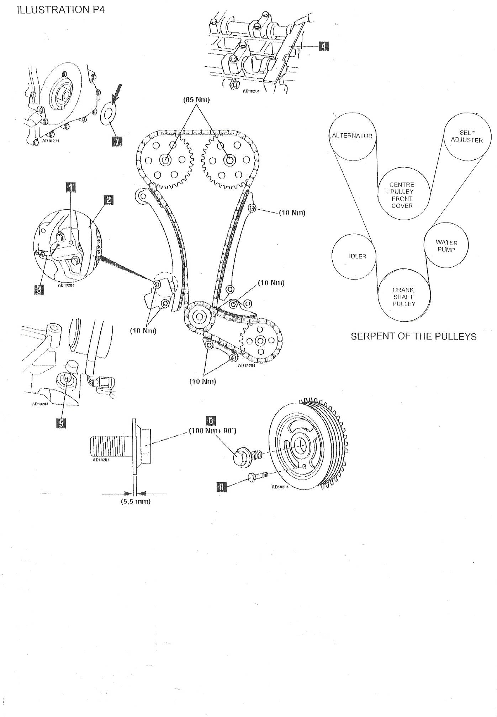
ILLUSTRATION P5

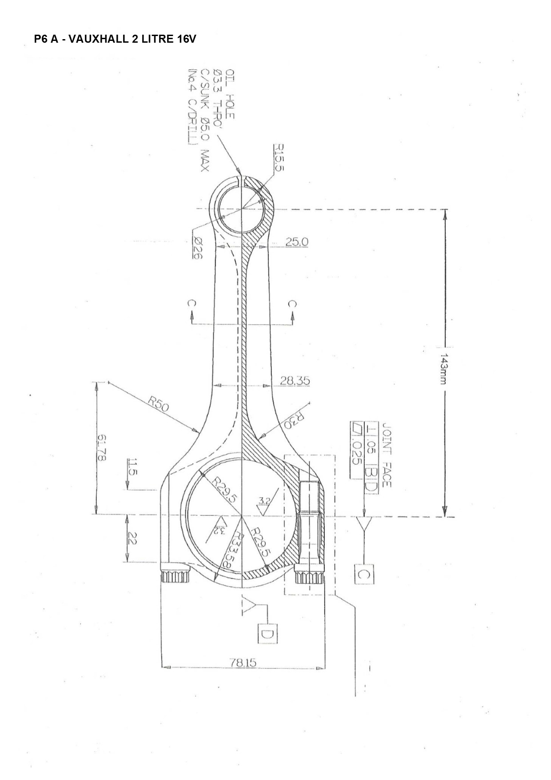

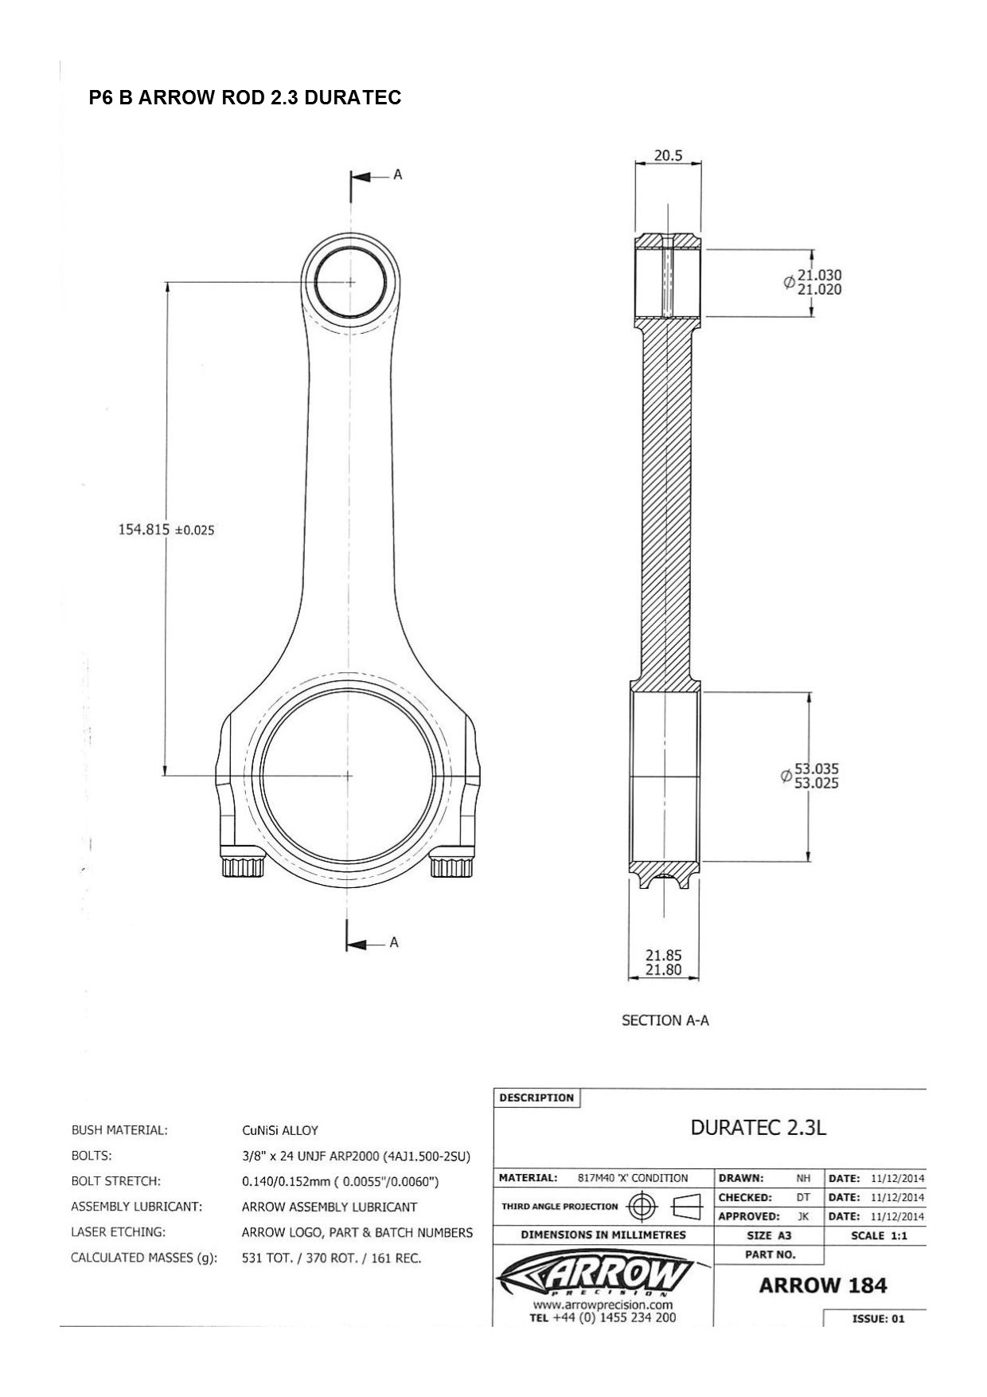

Illustration P7

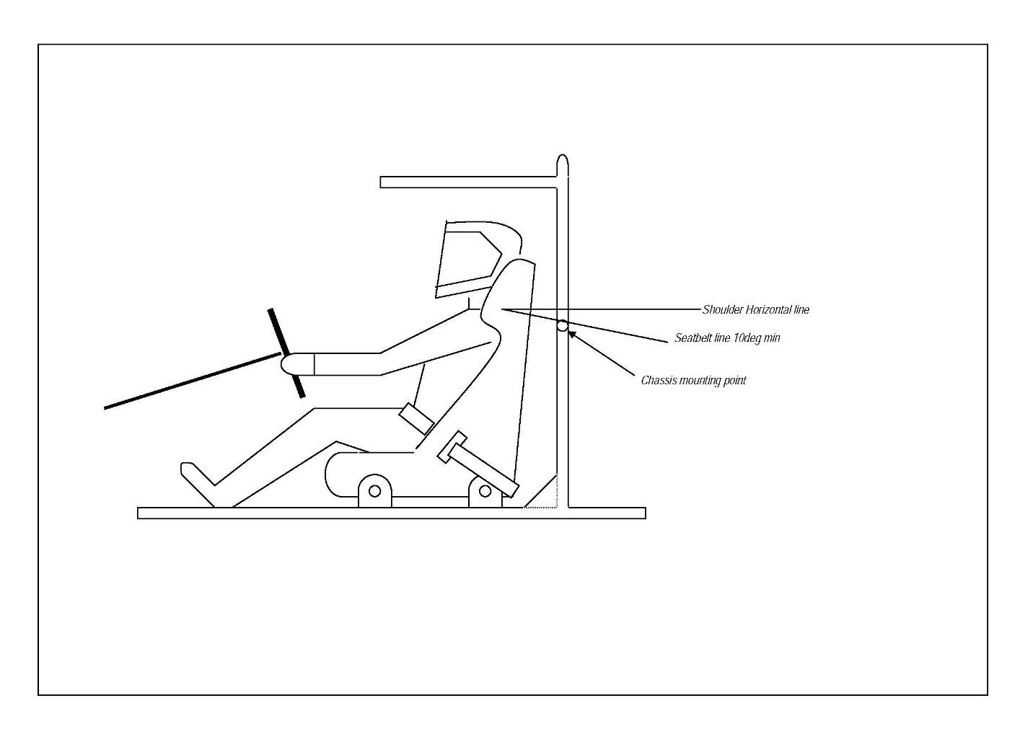

Illustration P8
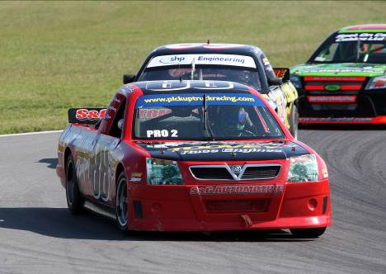
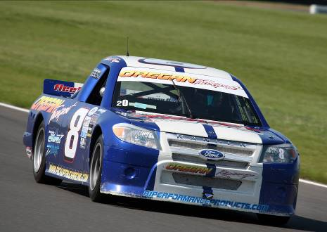
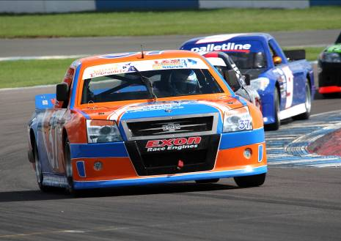
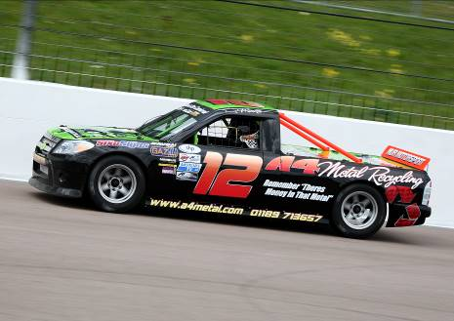
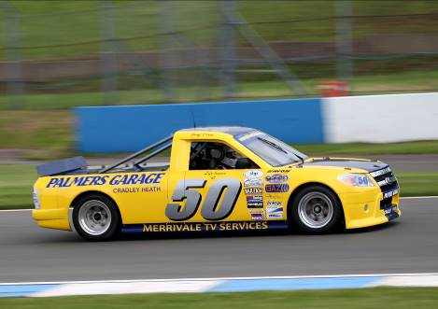
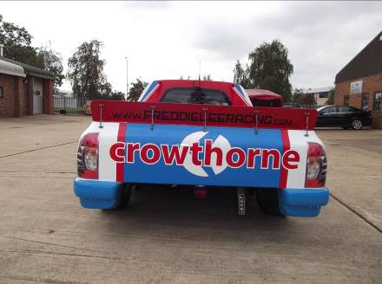

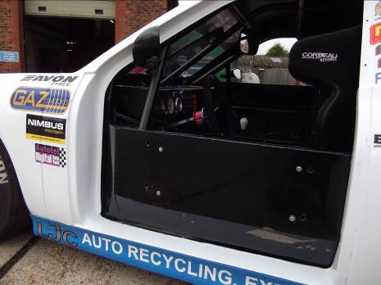
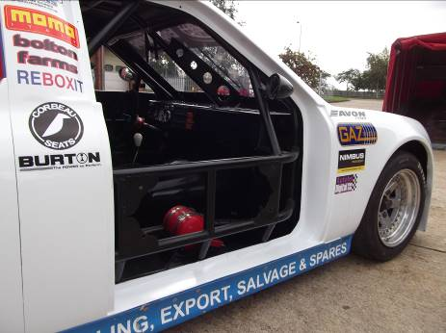

Current position of brake light
Area for new brake lights to be fitted

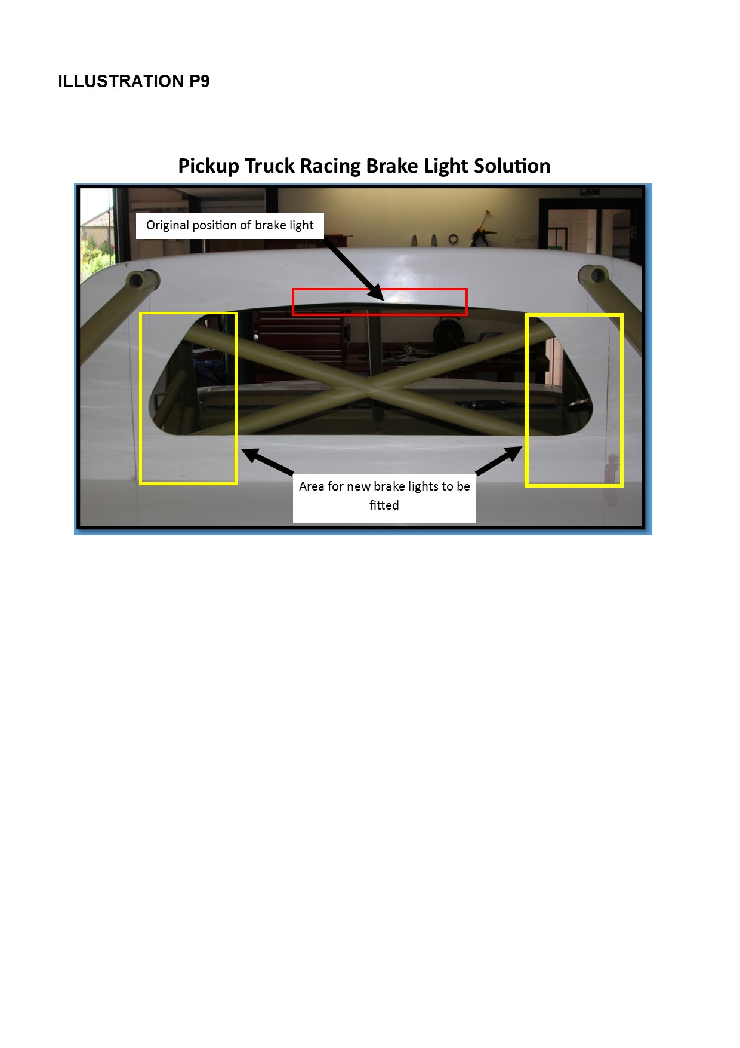

6. APPENDICES

The following Commercial Regulations are “contractual” between the Entrant and / or Driver and the Organisers and / or Promoters and are not considered by MSA. Accordingly, the application of these Commercial Regulations by the Organisers and / or Promoters will not be subject to the Judicial processes of either the Championship Stewards and / or the MSA / MSC.

  - Race Organising Clubs and Contacts:

British Automobile Racing Club Ltd (BARC)
Thruxton Circuit PO, Andover, Hampshire, SP11 8PN
Tel: 01264 882200 Fax: 01264 882233

Pickup Truck Racing Ltd
7 Faraday Road Business Park
Littleport, Cambridgeshire, CB6 1PE
Tel: 01353 861168 Fax. 01353 861877

6.2 Commercial Undertakings

6.2.1 Undertakings.

- The primary objective of the Pickup Truck Racing Championship, through drivers, team principles, team members and officials is to entertain the paying public. The Championship organisers have contractual rights with the promoters, event organisers and circuit owners to ensure agreement terms are met. The Pickup Truck Racing management team are required to achieve this by implementation and interpretation of the Rules and Regulations of the Championship.

- The majority of the Trucks in the championship are owned by the driver therefore any communication from Pickup Truck Racing organisation, the operating clubs or event management will be via the driver.

- The rules and regulations set forth herein are designed to provide for the orderly conduct of racing events and to establish the minimum requirements acceptable for such events. These rules and regulations shall govern the condition of all events and by participating in these events all participants are deemed to have agreed to these rules and regulations. No expressed or implied warranty of safety shall result from publications of or compliance with these rules and regulations. They are intended as a guide for the conduct of the sport and are in no way a guarantee against injury or death to a participant, spectator or official.

- All competitors, team members (mechanics etc.), manufacturers and persons associated with any of the above agree to be bound by the regulations including any amendments, variations or statements relating to the Championship.

- Drivers, and/or Truck owners shall not have any claim against Pickup Truck Racing Ltd. or its Officials or Race Organisers by reason of disqualification or damage of either personal injury or personal property as far as is possible under English Law.

6.2.2 Conduct, Penalties, etc.

- All persons admitted to the pit or any other restricted area at any event must obey all rules and regulations set down herein. Each person so admitted must complete and sign all releases of liability requested by the organisers.

- All authorised personnel entering any restricted area at an event must conduct themselves in an orderly manner not detrimental to the Championship. Complete attire including shirt, trousers and shoes is mandatory at all times.

- Failure to take part in any of the driver introductions, autograph sessions or official presentations of an event without permission of the Championship Manager or Championship Co-ordinator may result in application of penalties.

- Verbal or physical abuse of a Pickup Truck Racing Official, agent or representative and/or the use of improper language are strictly prohibited. Disorderly behaviour in any restricted area will be referred to the Clerk of the Course and Championship Management who may subject offenders to suspension and/or fine under their powers within these Regulations and Commercial Undertakings.

- On the result of CR 6.2.2.e. Pickup Truck Racing is within its rights to withdraw the offending competitor from nominal number of rounds or in full from the Championship. On this action the retained bond for entry fees will serve as the fine.

- Use of any alcohol, controlled substance or drug that may alter an individual’s ability to conduct themselves safely at an event is prohibited under H39-46. Certain Prescription drugs may also be considered subject to the same prohibition. Violation or suspicion of violation of this regulation may cause the offender and any entrant or driver he/she represents to immediate exclusion and possible fine at the discretion of the Clerk of the Course.

- It is the driver’s responsibility to control the actions of all his/her crew members during the time they are attending an event. It is the driver’s responsibility to ensure that all team members and guests meet all curfews, timetables and restrictions.

- It is the responsibility of the driver and/or team principle to ensure that no member or associated member of their team publishes any adverse or detrimental statement liable to bring the championship into disrepute via the media and/or internet.

- Pickup Truck Racing is within its rights to impose a fine. This can be imposed on a driver, crew chief, spotter or a crew member of the team. The fine can be imposed for any action deemed to contravene the Regulations and Commercial undertaking of Pickup Truck Racing. The value of the fine will be dependant on the nature of the incident.

- Pickup Truck Racing is within its rights to impose Championship point deductions for infringements by driver, crew chief, spotter or a crew member of the team. The point deductions can be imposed for any action deemed to contravene the Regulations and commercial undertakings of Pickup Truck Racing. The value of the point deductions will be dependant on the nature of the incident.

6.2.3 Media, Sponsorship, etc.

All participants empower Pickup Truck Racing to represent them in assigning rights for reproduction of permitted race events by electronic and/or print media and automatically assign rights to utilize their names, likeness, etc. in the media related materials and/or advertising of permitted race events.

All Trucks must carry sponsors logos in accordance with illustration H1.

The Championship Promoters reserve the right to exploit image rights including exploitation through any written, printed, filmed, taped, digital, analogical or electronic media whether exposed through TV and radio broadcasting (including advertisements), cinemas, the internet, emailing, texting, imaging, video, electronic and/or digital games, posters, press releases, event programmes, newspapers, magazines, promotional booklets, advertising leaflets, packaging and admission tickets. These rights are reserved for as long as the Championship promoter wishes, free of charge, such rights extending, without further consent, to sponsors and commercial partners of the Championship promoter from time to time as well as its successors in title.

“Image” includes likenesses of drivers, Trucks and team equipment transmitted from and/ or captured and / or produced within the confines of a Pickup Truck Racing event whether or not on the race circuit; whether stationary or moving by hand, film, tape, digitally, analogically, electronically or any other method.
“Image rights” means the right to exploit any image, for whatever purpose including promoting commercial interests, whether or not any such image contains the intellectual property of any entrant, team, driver, sponsor or third party.

6.2.4 Team Organisation.

- All-terrain vehicles (ATV’s) are permitted in the pit area for towing race Trucks or pit trolleys only and may only be use for such up to 5 minutes prior to the circuit opening and must then be removed from the pit area. Other use of such vehicles in the paddock area is restricted to legitimate team business and they must not be used for recreational use.

- All Trucks and race transporters must clearly show the number assigned to the Truck owner by Pickup Truck Racing.

6.2.5 Advertising

No advertising of tobacco or tobacco products is permitted in any shape or form in the Championship. Additionally, any products that are not permitted to be advertised on UK television are prohibited.
The Championship Manager reserves the right to censor any advertising deemed to be unsuitable and participation at an event may be prohibited until such advertising is changed.

No advertising or statements on the Truck, team vehicles, or on Drivers’ race clothing or team clothing is allowed which may reasonably be considered unsuitable or offensive to the Championship Promoters and organisers, or their sponsors.

The Championship Promoters reserve the right, in maintaining a positive public image for the sport, to approve or disapprove any advertising, sponsorship, message or similar agreement in connection with any event. The decision of the Championship Promoters is final in such matters.

No advertising or statements on the race Truck or the Drivers’ race clothing is permitted to conflict with the Championship sponsors without written approval of the Championship Promoters.

Advertising is permitted on the areas identified in the drawings in illustration H1.

6.2.6 Television

The Championship Promoters, through their nominated film production companies have exclusive broadcast, recoding, cable, satellite, digital, video, internet and interactive rights and rights to all other mediums to film and record the participation of the Driver, Spotter, Sponsor, and any other team member I the events and activities throughout the Championship and to licence, assign or otherwise deal with such rights and/ or film and recording.

The competitor accepts without reservation or recourse the surrender of his/her rights (if any) in such matters which may then be used at the Championship Promoters discretion.

It will be mandatory to carry on-board cameras if requested to do so by the Championship Promoters or Organisers.

All competitors advised that they are to carry on-board television cameras, may be required to have the approved Championship logo in a position visible to a forward facing on-board camera. The decision for the positioning of this logo rests solely with the Championship Promoters and their nominated film production company, subject to the performance of the Truck not being impaired.

No other publicity material that is visible to an on-board camera will be allowed on the Truck.

Any competitor who fails to meet these requirements will be penalised by the imposition of a fine of £500 on the first occasion by the Championship Coordinator and the material will not be released nor transmitted. Any further failures may be considered as a breach of these Commercial Undertakings.

Competitors are obliged to assist in promotion of the Championship/ Series by the granting of interviews when requested by the nominated film production company and any other reasonable requests of the Championship Promoters.

Competitors agree to authorise the Championship Promoters to use and licence the use of images and representatives of the vehicles and drivers competing in the Championship for the purposes of producing merchandise exploiting and promoting the Championship. For the avoidance of doubt the right to exploit the interactive games rights of the Championship rests only with the Championship promoters.

6.2.7 Hospitality

Hospitality/entertaining in any way or form of food/ drink is strictly prohibited in paddock areas without prior written consent from the circuit. Each team is permitted to provide general catering for team staff /drivers /family members only, up to a figure no greater than the number of permanent personnel passes issued by the series promoters to the team in respect of their entered Truck(s). Such catering operations can only be conducted in Paddock areas using vehicles granted Paddock access by the Championship Promoters/ Championship Coordinator.

6.2.8 Passes: As per issue via respective clubs and circuits.

6.2.9 Paddock vehicles

- Instructions regarding the parking of race transporters, motor homes, etc. will be issued.

- Competition Trucks may only be moved in the pit or paddock areas with a current full road traffic license holder seated in the driver’s position and in full control of the Truck.

- A speed limit of 10 mph applies in the paddock at each Championship meeting.

- Pit bikes etc. may not be used for recreational purposes and may only be used for team personnel on team business during the time limits specified in final instructions for each event.

